*# Import the dataset*  
**import** pandas **as** pd  
**import** numpy **as** np  
**import** matplotlib.pyplot **as** plt  
**import** seaborn **as** sns; sns.set(color_codes=True)

[2]

application_train = pd.read_csv('application_data.csv')  
application_train.head()

[3]

application_train.shape

(307511, 122)

[4]

application_train.columns

Index(['SK_ID_CURR', 'TARGET', 'NAME_CONTRACT_TYPE', 'CODE_GENDER',  
 'FLAG_OWN_CAR', 'FLAG_OWN_REALTY', 'CNT_CHILDREN', 'AMT_INCOME_TOTAL',  
 'AMT_CREDIT', 'AMT_ANNUITY',  
 ...  
 'FLAG_DOCUMENT_18', 'FLAG_DOCUMENT_19', 'FLAG_DOCUMENT_20',  
 'FLAG_DOCUMENT_21', 'AMT_REQ_CREDIT_BUREAU_HOUR',  
 'AMT_REQ_CREDIT_BUREAU_DAY', 'AMT_REQ_CREDIT_BUREAU_WEEK',  
 'AMT_REQ_CREDIT_BUREAU_MON', 'AMT_REQ_CREDIT_BUREAU_QRT',  
 'AMT_REQ_CREDIT_BUREAU_YEAR'],  
 dtype='object', length=122)

[5]

application_train.describe()

[6]

application_train.columns.values

array(['SK_ID_CURR', 'TARGET', 'NAME_CONTRACT_TYPE', 'CODE_GENDER',  
 'FLAG_OWN_CAR', 'FLAG_OWN_REALTY', 'CNT_CHILDREN',  
 'AMT_INCOME_TOTAL', 'AMT_CREDIT', 'AMT_ANNUITY', 'AMT_GOODS_PRICE',  
 'NAME_TYPE_SUITE', 'NAME_INCOME_TYPE', 'NAME_EDUCATION_TYPE',  
 'NAME_FAMILY_STATUS', 'NAME_HOUSING_TYPE',  
 'REGION_POPULATION_RELATIVE', 'DAYS_BIRTH', 'DAYS_EMPLOYED',  
 'DAYS_REGISTRATION', 'DAYS_ID_PUBLISH', 'OWN_CAR_AGE',  
 'FLAG_MOBIL', 'FLAG_EMP_PHONE', 'FLAG_WORK_PHONE',  
 'FLAG_CONT_MOBILE', 'FLAG_PHONE', 'FLAG_EMAIL', 'OCCUPATION_TYPE',  
 'CNT_FAM_MEMBERS', 'REGION_RATING_CLIENT',  
 'REGION_RATING_CLIENT_W_CITY', 'WEEKDAY_APPR_PROCESS_START',  
 'HOUR_APPR_PROCESS_START', 'REG_REGION_NOT_LIVE_REGION',  
 'REG_REGION_NOT_WORK_REGION', 'LIVE_REGION_NOT_WORK_REGION',  
 'REG_CITY_NOT_LIVE_CITY', 'REG_CITY_NOT_WORK_CITY',  
 'LIVE_CITY_NOT_WORK_CITY', 'ORGANIZATION_TYPE', 'EXT_SOURCE_1',  
 'EXT_SOURCE_2', 'EXT_SOURCE_3', 'APARTMENTS_AVG',  
 'BASEMENTAREA_AVG', 'YEARS_BEGINEXPLUATATION_AVG',  
 'YEARS_BUILD_AVG', 'COMMONAREA_AVG', 'ELEVATORS_AVG',  
 'ENTRANCES_AVG', 'FLOORSMAX_AVG', 'FLOORSMIN_AVG', 'LANDAREA_AVG',  
 'LIVINGAPARTMENTS_AVG', 'LIVINGAREA_AVG',  
 'NONLIVINGAPARTMENTS_AVG', 'NONLIVINGAREA_AVG', 'APARTMENTS_MODE',  
 'BASEMENTAREA_MODE', 'YEARS_BEGINEXPLUATATION_MODE',  
 'YEARS_BUILD_MODE', 'COMMONAREA_MODE', 'ELEVATORS_MODE',  
 'ENTRANCES_MODE', 'FLOORSMAX_MODE', 'FLOORSMIN_MODE',  
 'LANDAREA_MODE', 'LIVINGAPARTMENTS_MODE', 'LIVINGAREA_MODE',  
 'NONLIVINGAPARTMENTS_MODE', 'NONLIVINGAREA_MODE',  
 'APARTMENTS_MEDI', 'BASEMENTAREA_MEDI',  
 'YEARS_BEGINEXPLUATATION_MEDI', 'YEARS_BUILD_MEDI',  
 'COMMONAREA_MEDI', 'ELEVATORS_MEDI', 'ENTRANCES_MEDI',  
 'FLOORSMAX_MEDI', 'FLOORSMIN_MEDI', 'LANDAREA_MEDI',  
 'LIVINGAPARTMENTS_MEDI', 'LIVINGAREA_MEDI',  
 'NONLIVINGAPARTMENTS_MEDI', 'NONLIVINGAREA_MEDI',  
 'FONDKAPREMONT_MODE', 'HOUSETYPE_MODE', 'TOTALAREA_MODE',  
 'WALLSMATERIAL_MODE', 'EMERGENCYSTATE_MODE',  
 'OBS_30_CNT_SOCIAL_CIRCLE', 'DEF_30_CNT_SOCIAL_CIRCLE',  
 'OBS_60_CNT_SOCIAL_CIRCLE', 'DEF_60_CNT_SOCIAL_CIRCLE',  
 'DAYS_LAST_PHONE_CHANGE', 'FLAG_DOCUMENT_2', 'FLAG_DOCUMENT_3',  
 'FLAG_DOCUMENT_4', 'FLAG_DOCUMENT_5', 'FLAG_DOCUMENT_6',  
 'FLAG_DOCUMENT_7', 'FLAG_DOCUMENT_8', 'FLAG_DOCUMENT_9',  
 'FLAG_DOCUMENT_10', 'FLAG_DOCUMENT_11', 'FLAG_DOCUMENT_12',  
 'FLAG_DOCUMENT_13', 'FLAG_DOCUMENT_14', 'FLAG_DOCUMENT_15',  
 'FLAG_DOCUMENT_16', 'FLAG_DOCUMENT_17', 'FLAG_DOCUMENT_18',  
 'FLAG_DOCUMENT_19', 'FLAG_DOCUMENT_20', 'FLAG_DOCUMENT_21',  
 'AMT_REQ_CREDIT_BUREAU_HOUR', 'AMT_REQ_CREDIT_BUREAU_DAY',  
 'AMT_REQ_CREDIT_BUREAU_WEEK', 'AMT_REQ_CREDIT_BUREAU_MON',  
 'AMT_REQ_CREDIT_BUREAU_QRT', 'AMT_REQ_CREDIT_BUREAU_YEAR'],  
 dtype=object)

[7]

application_train.count()

SK_ID_CURR 307511  
TARGET 307511  
NAME_CONTRACT_TYPE 307511  
CODE_GENDER 307511  
FLAG_OWN_CAR 307511  
 ...   
AMT_REQ_CREDIT_BUREAU_DAY 265992  
AMT_REQ_CREDIT_BUREAU_WEEK 265992  
AMT_REQ_CREDIT_BUREAU_MON 265992  
AMT_REQ_CREDIT_BUREAU_QRT 265992  
AMT_REQ_CREDIT_BUREAU_YEAR 265992  
Length: 122, dtype: int64

[8]

len(application_train)

307511

[9]

application_train.isna().sum()

SK_ID_CURR 0  
TARGET 0  
NAME_CONTRACT_TYPE 0  
CODE_GENDER 0  
FLAG_OWN_CAR 0  
 ...   
AMT_REQ_CREDIT_BUREAU_DAY 41519  
AMT_REQ_CREDIT_BUREAU_WEEK 41519  
AMT_REQ_CREDIT_BUREAU_MON 41519  
AMT_REQ_CREDIT_BUREAU_QRT 41519  
AMT_REQ_CREDIT_BUREAU_YEAR 41519  
Length: 122, dtype: int64

[10]

application_train.isna().sum().sort_values(ascending=False).head(60)

COMMONAREA_MEDI 214865  
COMMONAREA_AVG 214865  
COMMONAREA_MODE 214865  
NONLIVINGAPARTMENTS_MODE 213514  
NONLIVINGAPARTMENTS_MEDI 213514  
NONLIVINGAPARTMENTS_AVG 213514  
FONDKAPREMONT_MODE 210295  
LIVINGAPARTMENTS_MEDI 210199  
LIVINGAPARTMENTS_MODE 210199  
LIVINGAPARTMENTS_AVG 210199  
FLOORSMIN_MEDI 208642  
FLOORSMIN_MODE 208642  
FLOORSMIN_AVG 208642  
YEARS_BUILD_MEDI 204488  
YEARS_BUILD_AVG 204488  
YEARS_BUILD_MODE 204488  
OWN_CAR_AGE 202929  
LANDAREA_MODE 182590  
LANDAREA_AVG 182590  
LANDAREA_MEDI 182590  
BASEMENTAREA_MEDI 179943  
BASEMENTAREA_AVG 179943  
BASEMENTAREA_MODE 179943  
EXT_SOURCE_1 173378  
NONLIVINGAREA_MEDI 169682  
NONLIVINGAREA_AVG 169682  
NONLIVINGAREA_MODE 169682  
ELEVATORS_MODE 163891  
ELEVATORS_AVG 163891  
ELEVATORS_MEDI 163891  
WALLSMATERIAL_MODE 156341  
APARTMENTS_MODE 156061  
APARTMENTS_AVG 156061  
APARTMENTS_MEDI 156061  
ENTRANCES_MEDI 154828  
ENTRANCES_MODE 154828  
ENTRANCES_AVG 154828  
LIVINGAREA_MEDI 154350  
LIVINGAREA_MODE 154350  
LIVINGAREA_AVG 154350  
HOUSETYPE_MODE 154297  
FLOORSMAX_MODE 153020  
FLOORSMAX_MEDI 153020  
FLOORSMAX_AVG 153020  
YEARS_BEGINEXPLUATATION_MEDI 150007  
YEARS_BEGINEXPLUATATION_AVG 150007  
YEARS_BEGINEXPLUATATION_MODE 150007  
TOTALAREA_MODE 148431  
EMERGENCYSTATE_MODE 145755  
OCCUPATION_TYPE 96391  
EXT_SOURCE_3 60965  
AMT_REQ_CREDIT_BUREAU_QRT 41519  
AMT_REQ_CREDIT_BUREAU_YEAR 41519  
AMT_REQ_CREDIT_BUREAU_WEEK 41519  
AMT_REQ_CREDIT_BUREAU_MON 41519  
AMT_REQ_CREDIT_BUREAU_DAY 41519  
AMT_REQ_CREDIT_BUREAU_HOUR 41519  
NAME_TYPE_SUITE 1292  
OBS_30_CNT_SOCIAL_CIRCLE 1021  
OBS_60_CNT_SOCIAL_CIRCLE 1021  
dtype: int64

[11]

application_train.shape

(307511, 122)

[12]

x = len(application_train)/2  
x

153755.5

[13]

type(application_train)

pandas.core.frame.DataFrame

[14]

application_train.columns[application_train.isnull().sum() < 153755]

Index(['SK_ID_CURR', 'TARGET', 'NAME_CONTRACT_TYPE', 'CODE_GENDER',  
 'FLAG_OWN_CAR', 'FLAG_OWN_REALTY', 'CNT_CHILDREN', 'AMT_INCOME_TOTAL',  
 'AMT_CREDIT', 'AMT_ANNUITY', 'AMT_GOODS_PRICE', 'NAME_TYPE_SUITE',  
 'NAME_INCOME_TYPE', 'NAME_EDUCATION_TYPE', 'NAME_FAMILY_STATUS',  
 'NAME_HOUSING_TYPE', 'REGION_POPULATION_RELATIVE', 'DAYS_BIRTH',  
 'DAYS_EMPLOYED', 'DAYS_REGISTRATION', 'DAYS_ID_PUBLISH', 'FLAG_MOBIL',  
 'FLAG_EMP_PHONE', 'FLAG_WORK_PHONE', 'FLAG_CONT_MOBILE', 'FLAG_PHONE',  
 'FLAG_EMAIL', 'OCCUPATION_TYPE', 'CNT_FAM_MEMBERS',  
 'REGION_RATING_CLIENT', 'REGION_RATING_CLIENT_W_CITY',  
 'WEEKDAY_APPR_PROCESS_START', 'HOUR_APPR_PROCESS_START',  
 'REG_REGION_NOT_LIVE_REGION', 'REG_REGION_NOT_WORK_REGION',  
 'LIVE_REGION_NOT_WORK_REGION', 'REG_CITY_NOT_LIVE_CITY',  
 'REG_CITY_NOT_WORK_CITY', 'LIVE_CITY_NOT_WORK_CITY',  
 'ORGANIZATION_TYPE', 'EXT_SOURCE_2', 'EXT_SOURCE_3',  
 'YEARS_BEGINEXPLUATATION_AVG', 'FLOORSMAX_AVG',  
 'YEARS_BEGINEXPLUATATION_MODE', 'FLOORSMAX_MODE',  
 'YEARS_BEGINEXPLUATATION_MEDI', 'FLOORSMAX_MEDI', 'TOTALAREA_MODE',  
 'EMERGENCYSTATE_MODE', 'OBS_30_CNT_SOCIAL_CIRCLE',  
 'DEF_30_CNT_SOCIAL_CIRCLE', 'OBS_60_CNT_SOCIAL_CIRCLE',  
 'DEF_60_CNT_SOCIAL_CIRCLE', 'DAYS_LAST_PHONE_CHANGE', 'FLAG_DOCUMENT_2',  
 'FLAG_DOCUMENT_3', 'FLAG_DOCUMENT_4', 'FLAG_DOCUMENT_5',  
 'FLAG_DOCUMENT_6', 'FLAG_DOCUMENT_7', 'FLAG_DOCUMENT_8',  
 'FLAG_DOCUMENT_9', 'FLAG_DOCUMENT_10', 'FLAG_DOCUMENT_11',  
 'FLAG_DOCUMENT_12', 'FLAG_DOCUMENT_13', 'FLAG_DOCUMENT_14',  
 'FLAG_DOCUMENT_15', 'FLAG_DOCUMENT_16', 'FLAG_DOCUMENT_17',  
 'FLAG_DOCUMENT_18', 'FLAG_DOCUMENT_19', 'FLAG_DOCUMENT_20',  
 'FLAG_DOCUMENT_21', 'AMT_REQ_CREDIT_BUREAU_HOUR',  
 'AMT_REQ_CREDIT_BUREAU_DAY', 'AMT_REQ_CREDIT_BUREAU_WEEK',  
 'AMT_REQ_CREDIT_BUREAU_MON', 'AMT_REQ_CREDIT_BUREAU_QRT',  
 'AMT_REQ_CREDIT_BUREAU_YEAR'],  
 dtype='object')

[15]

len(application_train.columns[application_train.isnull().sum() < 153755])

81

[16]

application_train = application_train.columns[application_train.isnull().sum() < 153755]  
application_train.shape

(307511, 81)

[17]

application_train.head()

[18]

application_train.isna.sum,sortvalues(asc=false)

FLOORSMAX_AVG 153020  
FLOORSMAX_MEDI 153020  
FLOORSMAX_MODE 153020  
YEARS_BEGINEXPLUATATION_AVG 150007  
YEARS_BEGINEXPLUATATION_MEDI 150007  
YEARS_BEGINEXPLUATATION_MODE 150007  
TOTALAREA_MODE 148431  
EMERGENCYSTATE_MODE 145755  
OCCUPATION_TYPE 96391  
EXT_SOURCE_3 60965  
AMT_REQ_CREDIT_BUREAU_YEAR 41519  
AMT_REQ_CREDIT_BUREAU_QRT 41519  
AMT_REQ_CREDIT_BUREAU_HOUR 41519  
AMT_REQ_CREDIT_BUREAU_DAY 41519  
AMT_REQ_CREDIT_BUREAU_WEEK 41519  
AMT_REQ_CREDIT_BUREAU_MON 41519  
NAME_TYPE_SUITE 1292  
DEF_60_CNT_SOCIAL_CIRCLE 1021  
OBS_30_CNT_SOCIAL_CIRCLE 1021  
DEF_30_CNT_SOCIAL_CIRCLE 1021  
OBS_60_CNT_SOCIAL_CIRCLE 1021  
EXT_SOURCE_2 660  
AMT_GOODS_PRICE 278  
AMT_ANNUITY 12  
CNT_FAM_MEMBERS 2  
DAYS_LAST_PHONE_CHANGE 1  
FLAG_DOCUMENT_5 0  
DAYS_ID_PUBLISH 0  
DAYS_BIRTH 0  
DAYS_EMPLOYED 0  
DAYS_REGISTRATION 0  
FLAG_MOBIL 0  
NAME_HOUSING_TYPE 0  
FLAG_EMP_PHONE 0  
FLAG_WORK_PHONE 0  
FLAG_CONT_MOBILE 0  
FLAG_PHONE 0  
FLAG_EMAIL 0  
REGION_POPULATION_RELATIVE 0  
NAME_EDUCATION_TYPE 0  
NAME_FAMILY_STATUS 0  
NAME_INCOME_TYPE 0  
FLAG_DOCUMENT_21 0  
AMT_CREDIT 0  
AMT_INCOME_TOTAL 0  
CNT_CHILDREN 0  
FLAG_OWN_REALTY 0  
FLAG_OWN_CAR 0  
CODE_GENDER 0  
NAME_CONTRACT_TYPE 0  
TARGET 0  
FLAG_DOCUMENT_20 0  
REGION_RATING_CLIENT 0  
FLAG_DOCUMENT_4 0  
REGION_RATING_CLIENT_W_CITY 0  
FLAG_DOCUMENT_3 0  
FLAG_DOCUMENT_2 0  
FLAG_DOCUMENT_6 0  
FLAG_DOCUMENT_7 0  
FLAG_DOCUMENT_8 0  
dtype: int64

[19]

*# Categorical columns are:*  
  
selectdtypes

['NAME_INCOME_TYPE',  
 'ORGANIZATION_TYPE',  
 'NAME_CONTRACT_TYPE',  
 'WEEKDAY_APPR_PROCESS_START',  
 'NAME_FAMILY_STATUS',  
 'NAME_EDUCATION_TYPE',  
 'OCCUPATION_TYPE',  
 'NAME_TYPE_SUITE',  
 'CODE_GENDER',  
 'FLAG_OWN_REALTY',  
 'EMERGENCYSTATE_MODE',  
 'FLAG_OWN_CAR',  
 'NAME_HOUSING_TYPE']

[20]

*# Numerical columns are:*

Index(['SK_ID_CURR', 'TARGET', 'CNT_CHILDREN', 'AMT_INCOME_TOTAL',  
 'AMT_CREDIT', 'AMT_ANNUITY', 'AMT_GOODS_PRICE',  
 'REGION_POPULATION_RELATIVE', 'DAYS_BIRTH', 'DAYS_EMPLOYED',  
 'DAYS_REGISTRATION', 'DAYS_ID_PUBLISH', 'FLAG_MOBIL', 'FLAG_EMP_PHONE',  
 'FLAG_WORK_PHONE', 'FLAG_CONT_MOBILE', 'FLAG_PHONE', 'FLAG_EMAIL',  
 'CNT_FAM_MEMBERS', 'REGION_RATING_CLIENT',  
 'REGION_RATING_CLIENT_W_CITY', 'HOUR_APPR_PROCESS_START',  
 'REG_REGION_NOT_LIVE_REGION', 'REG_REGION_NOT_WORK_REGION',  
 'LIVE_REGION_NOT_WORK_REGION', 'REG_CITY_NOT_LIVE_CITY',  
 'REG_CITY_NOT_WORK_CITY', 'LIVE_CITY_NOT_WORK_CITY', 'EXT_SOURCE_2',  
 'EXT_SOURCE_3', 'YEARS_BEGINEXPLUATATION_AVG', 'FLOORSMAX_AVG',  
 'YEARS_BEGINEXPLUATATION_MODE', 'FLOORSMAX_MODE',  
 'YEARS_BEGINEXPLUATATION_MEDI', 'FLOORSMAX_MEDI', 'TOTALAREA_MODE',  
 'OBS_30_CNT_SOCIAL_CIRCLE', 'DEF_30_CNT_SOCIAL_CIRCLE',  
 'OBS_60_CNT_SOCIAL_CIRCLE', 'DEF_60_CNT_SOCIAL_CIRCLE',  
 'DAYS_LAST_PHONE_CHANGE', 'FLAG_DOCUMENT_2', 'FLAG_DOCUMENT_3',  
 'FLAG_DOCUMENT_4', 'FLAG_DOCUMENT_5', 'FLAG_DOCUMENT_6',  
 'FLAG_DOCUMENT_7', 'FLAG_DOCUMENT_8', 'FLAG_DOCUMENT_9',  
 'FLAG_DOCUMENT_10', 'FLAG_DOCUMENT_11', 'FLAG_DOCUMENT_12',  
 'FLAG_DOCUMENT_13', 'FLAG_DOCUMENT_14', 'FLAG_DOCUMENT_15',  
 'FLAG_DOCUMENT_16', 'FLAG_DOCUMENT_17', 'FLAG_DOCUMENT_18',  
 'FLAG_DOCUMENT_19', 'FLAG_DOCUMENT_20', 'FLAG_DOCUMENT_21',  
 'AMT_REQ_CREDIT_BUREAU_HOUR', 'AMT_REQ_CREDIT_BUREAU_DAY',  
 'AMT_REQ_CREDIT_BUREAU_WEEK', 'AMT_REQ_CREDIT_BUREAU_MON',  
 'AMT_REQ_CREDIT_BUREAU_QRT', 'AMT_REQ_CREDIT_BUREAU_YEAR'],  
 dtype='object')

[21]

application_train.shape

(307511, 81)

[22]

*# Not to be done*  
application_train = application_train.sample(25000)  
application_train.shape

(25000, 81)

[23]

application_train.head()

[24]

application_train.columns

Index(['SK_ID_CURR', 'TARGET', 'NAME_CONTRACT_TYPE', 'CODE_GENDER',  
 'FLAG_OWN_CAR', 'FLAG_OWN_REALTY', 'CNT_CHILDREN', 'AMT_INCOME_TOTAL',  
 'AMT_CREDIT', 'AMT_ANNUITY', 'AMT_GOODS_PRICE', 'NAME_TYPE_SUITE',  
 'NAME_INCOME_TYPE', 'NAME_EDUCATION_TYPE', 'NAME_FAMILY_STATUS',  
 'NAME_HOUSING_TYPE', 'REGION_POPULATION_RELATIVE', 'DAYS_BIRTH',  
 'DAYS_EMPLOYED', 'DAYS_REGISTRATION', 'DAYS_ID_PUBLISH', 'FLAG_MOBIL',  
 'FLAG_EMP_PHONE', 'FLAG_WORK_PHONE', 'FLAG_CONT_MOBILE', 'FLAG_PHONE',  
 'FLAG_EMAIL', 'OCCUPATION_TYPE', 'CNT_FAM_MEMBERS',  
 'REGION_RATING_CLIENT', 'REGION_RATING_CLIENT_W_CITY',  
 'WEEKDAY_APPR_PROCESS_START', 'HOUR_APPR_PROCESS_START',  
 'REG_REGION_NOT_LIVE_REGION', 'REG_REGION_NOT_WORK_REGION',  
 'LIVE_REGION_NOT_WORK_REGION', 'REG_CITY_NOT_LIVE_CITY',  
 'REG_CITY_NOT_WORK_CITY', 'LIVE_CITY_NOT_WORK_CITY',  
 'ORGANIZATION_TYPE', 'EXT_SOURCE_2', 'EXT_SOURCE_3',  
 'YEARS_BEGINEXPLUATATION_AVG', 'FLOORSMAX_AVG',  
 'YEARS_BEGINEXPLUATATION_MODE', 'FLOORSMAX_MODE',  
 'YEARS_BEGINEXPLUATATION_MEDI', 'FLOORSMAX_MEDI', 'TOTALAREA_MODE',  
 'EMERGENCYSTATE_MODE', 'OBS_30_CNT_SOCIAL_CIRCLE',  
 'DEF_30_CNT_SOCIAL_CIRCLE', 'OBS_60_CNT_SOCIAL_CIRCLE',  
 'DEF_60_CNT_SOCIAL_CIRCLE', 'DAYS_LAST_PHONE_CHANGE', 'FLAG_DOCUMENT_2',  
 'FLAG_DOCUMENT_3', 'FLAG_DOCUMENT_4', 'FLAG_DOCUMENT_5',  
 'FLAG_DOCUMENT_6', 'FLAG_DOCUMENT_7', 'FLAG_DOCUMENT_8',  
 'FLAG_DOCUMENT_9', 'FLAG_DOCUMENT_10', 'FLAG_DOCUMENT_11',  
 'FLAG_DOCUMENT_12', 'FLAG_DOCUMENT_13', 'FLAG_DOCUMENT_14',  
 'FLAG_DOCUMENT_15', 'FLAG_DOCUMENT_16', 'FLAG_DOCUMENT_17',  
 'FLAG_DOCUMENT_18', 'FLAG_DOCUMENT_19', 'FLAG_DOCUMENT_20',  
 'FLAG_DOCUMENT_21', 'AMT_REQ_CREDIT_BUREAU_HOUR',  
 'AMT_REQ_CREDIT_BUREAU_DAY', 'AMT_REQ_CREDIT_BUREAU_WEEK',  
 'AMT_REQ_CREDIT_BUREAU_MON', 'AMT_REQ_CREDIT_BUREAU_QRT',  
 'AMT_REQ_CREDIT_BUREAU_YEAR'],  
 dtype='object')

[25]

nulls = application_train.isnull().sum()  
nulls[nulls > 0]

AMT_GOODS_PRICE 31  
NAME_TYPE_SUITE 124  
OCCUPATION_TYPE 7791  
EXT_SOURCE_2 46  
EXT_SOURCE_3 4937  
YEARS_BEGINEXPLUATATION_AVG 12079  
FLOORSMAX_AVG 12333  
YEARS_BEGINEXPLUATATION_MODE 12079  
FLOORSMAX_MODE 12333  
YEARS_BEGINEXPLUATATION_MEDI 12079  
FLOORSMAX_MEDI 12333  
TOTALAREA_MODE 11949  
EMERGENCYSTATE_MODE 11737  
OBS_30_CNT_SOCIAL_CIRCLE 89  
DEF_30_CNT_SOCIAL_CIRCLE 89  
OBS_60_CNT_SOCIAL_CIRCLE 89  
DEF_60_CNT_SOCIAL_CIRCLE 89  
AMT_REQ_CREDIT_BUREAU_HOUR 3334  
AMT_REQ_CREDIT_BUREAU_DAY 3334  
AMT_REQ_CREDIT_BUREAU_WEEK 3334  
AMT_REQ_CREDIT_BUREAU_MON 3334  
AMT_REQ_CREDIT_BUREAU_QRT 3334  
AMT_REQ_CREDIT_BUREAU_YEAR 3334  
dtype: int64

Age:  
35  
43  
12  
NaN  
45  
54  
NaN  
54  
33  
54  
  
count -> 8  
len -> 10  
  
(8/10)*100 = 80% **is** the available value %age  
100 - 80% = 20% are the missing value %age

[26]

application_train.count()

SK_ID_CURR 25000  
TARGET 25000  
NAME_CONTRACT_TYPE 25000  
CODE_GENDER 25000  
FLAG_OWN_CAR 25000  
 ...   
AMT_REQ_CREDIT_BUREAU_DAY 21666  
AMT_REQ_CREDIT_BUREAU_WEEK 21666  
AMT_REQ_CREDIT_BUREAU_MON 21666  
AMT_REQ_CREDIT_BUREAU_QRT 21666  
AMT_REQ_CREDIT_BUREAU_YEAR 21666  
Length: 81, dtype: int64

[27]

len(application_train)

25000

[28]

train_missing = application_train.count()/len(application_train)  
train_missing

SK_ID_CURR 1.00000  
TARGET 1.00000  
NAME_CONTRACT_TYPE 1.00000  
CODE_GENDER 1.00000  
FLAG_OWN_CAR 1.00000  
 ...   
AMT_REQ_CREDIT_BUREAU_DAY 0.86664  
AMT_REQ_CREDIT_BUREAU_WEEK 0.86664  
AMT_REQ_CREDIT_BUREAU_MON 0.86664  
AMT_REQ_CREDIT_BUREAU_QRT 0.86664  
AMT_REQ_CREDIT_BUREAU_YEAR 0.86664  
Length: 81, dtype: float64

[29]

train_missing = (1 - train_missing)*100  
train_missing

SK_ID_CURR 0.000  
TARGET 0.000  
NAME_CONTRACT_TYPE 0.000  
CODE_GENDER 0.000  
FLAG_OWN_CAR 0.000  
 ...   
AMT_REQ_CREDIT_BUREAU_DAY 13.336  
AMT_REQ_CREDIT_BUREAU_WEEK 13.336  
AMT_REQ_CREDIT_BUREAU_MON 13.336  
AMT_REQ_CREDIT_BUREAU_QRT 13.336  
AMT_REQ_CREDIT_BUREAU_YEAR 13.336  
Length: 81, dtype: float64

[30]

train_missing.sort_values(ascending=False).head(60)

FLOORSMAX_AVG 49.332  
FLOORSMAX_MEDI 49.332  
FLOORSMAX_MODE 49.332  
YEARS_BEGINEXPLUATATION_AVG 48.316  
YEARS_BEGINEXPLUATATION_MEDI 48.316  
YEARS_BEGINEXPLUATATION_MODE 48.316  
TOTALAREA_MODE 47.796  
EMERGENCYSTATE_MODE 46.948  
OCCUPATION_TYPE 31.164  
EXT_SOURCE_3 19.748  
AMT_REQ_CREDIT_BUREAU_YEAR 13.336  
AMT_REQ_CREDIT_BUREAU_QRT 13.336  
AMT_REQ_CREDIT_BUREAU_HOUR 13.336  
AMT_REQ_CREDIT_BUREAU_DAY 13.336  
AMT_REQ_CREDIT_BUREAU_WEEK 13.336  
AMT_REQ_CREDIT_BUREAU_MON 13.336  
NAME_TYPE_SUITE 0.496  
DEF_60_CNT_SOCIAL_CIRCLE 0.356  
OBS_30_CNT_SOCIAL_CIRCLE 0.356  
DEF_30_CNT_SOCIAL_CIRCLE 0.356  
OBS_60_CNT_SOCIAL_CIRCLE 0.356  
EXT_SOURCE_2 0.184  
AMT_GOODS_PRICE 0.124  
FLAG_DOCUMENT_5 0.000  
NAME_FAMILY_STATUS 0.000  
FLAG_EMAIL 0.000  
FLAG_PHONE 0.000  
FLAG_CONT_MOBILE 0.000  
FLAG_WORK_PHONE 0.000  
FLAG_EMP_PHONE 0.000  
FLAG_MOBIL 0.000  
DAYS_ID_PUBLISH 0.000  
DAYS_REGISTRATION 0.000  
DAYS_EMPLOYED 0.000  
DAYS_BIRTH 0.000  
REGION_POPULATION_RELATIVE 0.000  
NAME_HOUSING_TYPE 0.000  
NAME_EDUCATION_TYPE 0.000  
CNT_FAM_MEMBERS 0.000  
NAME_INCOME_TYPE 0.000  
FLAG_DOCUMENT_21 0.000  
AMT_ANNUITY 0.000  
AMT_CREDIT 0.000  
AMT_INCOME_TOTAL 0.000  
CNT_CHILDREN 0.000  
FLAG_OWN_REALTY 0.000  
FLAG_OWN_CAR 0.000  
CODE_GENDER 0.000  
NAME_CONTRACT_TYPE 0.000  
TARGET 0.000  
FLAG_DOCUMENT_20 0.000  
REGION_RATING_CLIENT 0.000  
FLAG_DOCUMENT_4 0.000  
FLAG_DOCUMENT_15 0.000  
FLAG_DOCUMENT_3 0.000  
FLAG_DOCUMENT_2 0.000  
DAYS_LAST_PHONE_CHANGE 0.000  
FLAG_DOCUMENT_6 0.000  
FLAG_DOCUMENT_7 0.000  
FLAG_DOCUMENT_8 0.000  
dtype: float64

Missing value treatment  
  
As you can observe, there are lot of columns **with** missing values. There are some columns which has missing values around **or** more than 50%. Other columns has significantly less missing value. Also, the columns **for** which has missing values are around **or** more than 50% are mostly either mean, median **or** mode. So, there **is** no way one can replace these missing data. So, we will **not** consider these columns **for** analysis. We will consider other columns **for** analysis. Let's analyse the other columns.

[31]

application_train['FLOORSMAX_AVG'].head()

10864 0.1667  
250852 0.1667  
225261 NaN  
48543 NaN  
139310 NaN  
Name: FLOORSMAX_AVG, dtype: float64

[32]

application_train['FLOORSMAX_AVG'].mean()

0.22571756532724152

[33]

application_train['FLOORSMAX_AVG'].mode()

0 0.1667  
dtype: float64

[34]

application_train['FLOORSMAX_AVG'].describe()

count 12667.000000  
mean 0.225718  
std 0.144105  
min 0.000000  
25% 0.166700  
50% 0.166700  
75% 0.333300  
max 1.000000  
Name: FLOORSMAX_AVG, dtype: float64

[35]

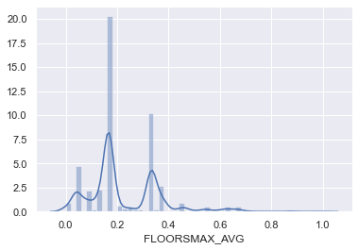

[36]

[37]

application_train['FLOORSMAX_AVG'].isna().sum()

0

[38]

sns.distplot(application_train['FLOORSMAX_AVG']);

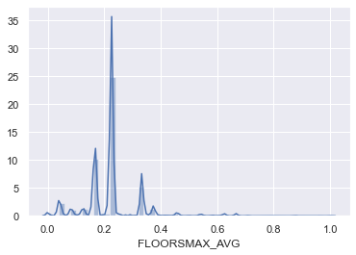

[39]

train_missing.sort_values(ascending=False).head(60)

FLOORSMAX_AVG 49.332  
FLOORSMAX_MEDI 49.332  
FLOORSMAX_MODE 49.332  
YEARS_BEGINEXPLUATATION_AVG 48.316  
YEARS_BEGINEXPLUATATION_MEDI 48.316  
YEARS_BEGINEXPLUATATION_MODE 48.316  
TOTALAREA_MODE 47.796  
EMERGENCYSTATE_MODE 46.948  
OCCUPATION_TYPE 31.164  
EXT_SOURCE_3 19.748  
AMT_REQ_CREDIT_BUREAU_YEAR 13.336  
AMT_REQ_CREDIT_BUREAU_QRT 13.336  
AMT_REQ_CREDIT_BUREAU_HOUR 13.336  
AMT_REQ_CREDIT_BUREAU_DAY 13.336  
AMT_REQ_CREDIT_BUREAU_WEEK 13.336  
AMT_REQ_CREDIT_BUREAU_MON 13.336  
NAME_TYPE_SUITE 0.496  
DEF_60_CNT_SOCIAL_CIRCLE 0.356  
OBS_30_CNT_SOCIAL_CIRCLE 0.356  
DEF_30_CNT_SOCIAL_CIRCLE 0.356  
OBS_60_CNT_SOCIAL_CIRCLE 0.356  
EXT_SOURCE_2 0.184  
AMT_GOODS_PRICE 0.124  
FLAG_DOCUMENT_5 0.000  
NAME_FAMILY_STATUS 0.000  
FLAG_EMAIL 0.000  
FLAG_PHONE 0.000  
FLAG_CONT_MOBILE 0.000  
FLAG_WORK_PHONE 0.000  
FLAG_EMP_PHONE 0.000  
FLAG_MOBIL 0.000  
DAYS_ID_PUBLISH 0.000  
DAYS_REGISTRATION 0.000  
DAYS_EMPLOYED 0.000  
DAYS_BIRTH 0.000  
REGION_POPULATION_RELATIVE 0.000  
NAME_HOUSING_TYPE 0.000  
NAME_EDUCATION_TYPE 0.000  
CNT_FAM_MEMBERS 0.000  
NAME_INCOME_TYPE 0.000  
FLAG_DOCUMENT_21 0.000  
AMT_ANNUITY 0.000  
AMT_CREDIT 0.000  
AMT_INCOME_TOTAL 0.000  
CNT_CHILDREN 0.000  
FLAG_OWN_REALTY 0.000  
FLAG_OWN_CAR 0.000  
CODE_GENDER 0.000  
NAME_CONTRACT_TYPE 0.000  
TARGET 0.000  
FLAG_DOCUMENT_20 0.000  
REGION_RATING_CLIENT 0.000  
FLAG_DOCUMENT_4 0.000  
FLAG_DOCUMENT_15 0.000  
FLAG_DOCUMENT_3 0.000  
FLAG_DOCUMENT_2 0.000  
DAYS_LAST_PHONE_CHANGE 0.000  
FLAG_DOCUMENT_6 0.000  
FLAG_DOCUMENT_7 0.000  
FLAG_DOCUMENT_8 0.000  
dtype: float64

Column: OCCUPATION_TYPE  
As you can see, OCCUPATION_TYPE column has 31% missing data, which **is** also a huge number. So, it would be approprite to remove this column, but **if** you go through this column, this seems to look important. So, we will **not** analyse this column.

[40]

application_train['OCCUPATION_TYPE'].head()

10864 High skill tech staff  
250852 Core staff  
225261 Core staff  
48543 Laborers  
139310 NaN  
Name: OCCUPATION_TYPE, dtype: object

[41]

*#application_train['OCCUPATION_TYPE']*

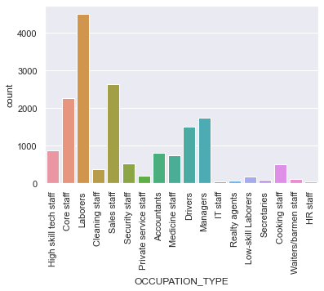

[42]

application_train['EXT_SOURCE_3'].head(10)

10864 0.171468  
250852 0.256706  
225261 0.726711  
48543 0.176653  
139310 0.540654  
253366 0.108924  
149247 0.600658  
124813 0.282248  
69716 0.177704  
270030 NaN  
Name: EXT_SOURCE_3, dtype: float64

[43]

*# Plotting the distribution*

<matplotlib.axes._subplots.AxesSubplot at 0x25d627bb160>

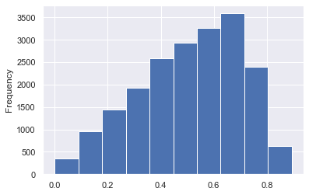

[44]

application_train['EXT_SOURCE_3'].mean()

0.5089481510656194

[45]

application_train['EXT_SOURCE_3'].mode()

0 0.713631  
dtype: float64

This data **is** a skewed normal distribution

Column: AMT_REQ_CREDIT_BUREAU_QRT

[46]

application_train['AMT_REQ_CREDIT_BUREAU_QRT'].head()

10864 0.0  
250852 0.0  
225261 0.0  
48543 0.0  
139310 0.0  
Name: AMT_REQ_CREDIT_BUREAU_QRT, dtype: float64

[47]

*#application_train['AMT_REQ_CREDIT_BUREAU_QRT'].plot.hist()*

<matplotlib.axes._subplots.AxesSubplot at 0x25d62836940>

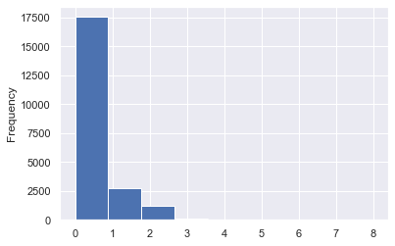

[48]

application_train.AMT_REQ_CREDIT_BUREAU_QRT.value_counts()

0.0 17537  
1.0 2744  
2.0 1195  
3.0 140  
4.0 41  
5.0 5  
8.0 2  
6.0 2  
Name: AMT_REQ_CREDIT_BUREAU_QRT, dtype: int64

[49]

application_train['AMT_REQ_CREDIT_BUREAU_QRT'].mean()

0.26636204190898183

[50]

application_train['AMT_REQ_CREDIT_BUREAU_QRT'].mode()

0 0.0  
dtype: float64

Since the column only takes discrete values, 1 **or** 0, so we cannot replace it by mean value. Here, we will replace it by mode.

[51]

application_train['AMT_REQ_CREDIT_BUREAU_QRT']=  
                application_train['AMT_REQ_CREDIT_BUREAU_QRT'].  
                    fillna(application_train['AMT_REQ_CREDIT_BUREAU_QRT'].mode().iloc[0])

[52]

application_train['AMT_REQ_CREDIT_BUREAU_QRT'].isna().sum()

0

[53]

train_missing.sort_values(ascending=False).head(60)

FLOORSMAX_AVG 49.332  
FLOORSMAX_MEDI 49.332  
FLOORSMAX_MODE 49.332  
YEARS_BEGINEXPLUATATION_AVG 48.316  
YEARS_BEGINEXPLUATATION_MEDI 48.316  
YEARS_BEGINEXPLUATATION_MODE 48.316  
TOTALAREA_MODE 47.796  
EMERGENCYSTATE_MODE 46.948  
OCCUPATION_TYPE 31.164  
EXT_SOURCE_3 19.748  
AMT_REQ_CREDIT_BUREAU_YEAR 13.336  
AMT_REQ_CREDIT_BUREAU_QRT 13.336  
AMT_REQ_CREDIT_BUREAU_HOUR 13.336  
AMT_REQ_CREDIT_BUREAU_DAY 13.336  
AMT_REQ_CREDIT_BUREAU_WEEK 13.336  
AMT_REQ_CREDIT_BUREAU_MON 13.336  
NAME_TYPE_SUITE 0.496  
DEF_60_CNT_SOCIAL_CIRCLE 0.356  
OBS_30_CNT_SOCIAL_CIRCLE 0.356  
DEF_30_CNT_SOCIAL_CIRCLE 0.356  
OBS_60_CNT_SOCIAL_CIRCLE 0.356  
EXT_SOURCE_2 0.184  
AMT_GOODS_PRICE 0.124  
FLAG_DOCUMENT_5 0.000  
NAME_FAMILY_STATUS 0.000  
FLAG_EMAIL 0.000  
FLAG_PHONE 0.000  
FLAG_CONT_MOBILE 0.000  
FLAG_WORK_PHONE 0.000  
FLAG_EMP_PHONE 0.000  
FLAG_MOBIL 0.000  
DAYS_ID_PUBLISH 0.000  
DAYS_REGISTRATION 0.000  
DAYS_EMPLOYED 0.000  
DAYS_BIRTH 0.000  
REGION_POPULATION_RELATIVE 0.000  
NAME_HOUSING_TYPE 0.000  
NAME_EDUCATION_TYPE 0.000  
CNT_FAM_MEMBERS 0.000  
NAME_INCOME_TYPE 0.000  
FLAG_DOCUMENT_21 0.000  
AMT_ANNUITY 0.000  
AMT_CREDIT 0.000  
AMT_INCOME_TOTAL 0.000  
CNT_CHILDREN 0.000  
FLAG_OWN_REALTY 0.000  
FLAG_OWN_CAR 0.000  
CODE_GENDER 0.000  
NAME_CONTRACT_TYPE 0.000  
TARGET 0.000  
FLAG_DOCUMENT_20 0.000  
REGION_RATING_CLIENT 0.000  
FLAG_DOCUMENT_4 0.000  
FLAG_DOCUMENT_15 0.000  
FLAG_DOCUMENT_3 0.000  
FLAG_DOCUMENT_2 0.000  
DAYS_LAST_PHONE_CHANGE 0.000  
FLAG_DOCUMENT_6 0.000  
FLAG_DOCUMENT_7 0.000  
FLAG_DOCUMENT_8 0.000  
dtype: float64

Column: AMT_REQ_CREDIT_BUREAU_WEEK

[54]

application_train['AMT_REQ_CREDIT_BUREAU_WEEK'].head(10)

10864 0.0  
250852 0.0  
225261 0.0  
48543 0.0  
139310 0.0  
253366 0.0  
149247 0.0  
124813 0.0  
69716 0.0  
270030 NaN  
Name: AMT_REQ_CREDIT_BUREAU_WEEK, dtype: float64

[55]

num_unique_values =  len(application_train.AMT_REQ_CREDIT_BUREAU_WEEK.unique())  
application_train['AMT_REQ_CREDIT_BUREAU_WEEK'].plot.hist(bins = num_unique_values)

<matplotlib.axes._subplots.AxesSubplot at 0x25d62827100>

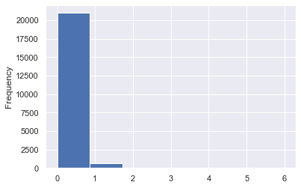

As you can see, mostly the values are 0's. So, this column is mostly acting as a constant and has no variation. So, we can ignore this column for analysis.

[56]

application_train['DEF_60_CNT_SOCIAL_CIRCLE'].sample(5)

165976 0.0  
142356 1.0  
160193 0.0  
297324 0.0  
40759 0.0  
Name: DEF_60_CNT_SOCIAL_CIRCLE, dtype: float64

[57]

application_train['DEF_60_CNT_SOCIAL_CIRCLE'].describe()

count 24911.000000  
mean 0.098029  
std 0.360350  
min 0.000000  
25% 0.000000  
50% 0.000000  
75% 0.000000  
max 6.000000  
Name: DEF_60_CNT_SOCIAL_CIRCLE, dtype: float64

[58]

application_train['DEF_60_CNT_SOCIAL_CIRCLE'].isna().sum()

89

[59]

application_train['DEF_60_CNT_SOCIAL_CIRCLE'].unique()

array([ 0., 1., nan, 2., 3., 5., 4., 6.])

[60]

application_train['DEF_60_CNT_SOCIAL_CIRCLE'].mean()

0.09802898318012124

[61]

application_train['DEF_60_CNT_SOCIAL_CIRCLE'].median()

0.0

[62]

application_train['DEF_60_CNT_SOCIAL_CIRCLE'].mode()

0 0.0  
dtype: float64

[63]

*#application_train['DEF_60_CNT_SOCIAL_CIRCLE'].count.plot.hist()*

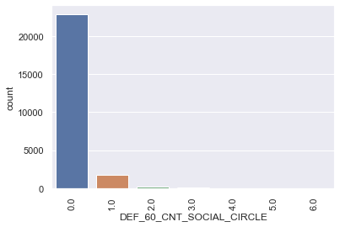

[64]

application_train['AMT_REQ_CREDIT_BUREAU_QRT']=application_train['DEF_60_CNT_SOCIAL_CIRCLE'].fillna(  
                application_train['DEF_60_CNT_SOCIAL_CIRCLE'].mode().iloc[0])

[65]

application_train['AMT_REQ_CREDIT_BUREAU_QRT'].isna().sum()

0

[66]

*#application_train['DEF_60_CNT_SOCIAL_CIRCLE'].count.plot.hist()*



[67]

*# Categorical columns are:*  
  
list(set(application_train.columns) - set(application_train.describe().columns))

['NAME_INCOME_TYPE',  
 'ORGANIZATION_TYPE',  
 'NAME_CONTRACT_TYPE',  
 'WEEKDAY_APPR_PROCESS_START',  
 'NAME_FAMILY_STATUS',  
 'NAME_EDUCATION_TYPE',  
 'OCCUPATION_TYPE',  
 'NAME_TYPE_SUITE',  
 'CODE_GENDER',  
 'FLAG_OWN_REALTY',  
 'EMERGENCYSTATE_MODE',  
 'FLAG_OWN_CAR',  
 'NAME_HOUSING_TYPE']

[68]

*# Numerical columns are:*  
application_train.describe().columns

Index(['SK_ID_CURR', 'TARGET', 'CNT_CHILDREN', 'AMT_INCOME_TOTAL',  
 'AMT_CREDIT', 'AMT_ANNUITY', 'AMT_GOODS_PRICE',  
 'REGION_POPULATION_RELATIVE', 'DAYS_BIRTH', 'DAYS_EMPLOYED',  
 'DAYS_REGISTRATION', 'DAYS_ID_PUBLISH', 'FLAG_MOBIL', 'FLAG_EMP_PHONE',  
 'FLAG_WORK_PHONE', 'FLAG_CONT_MOBILE', 'FLAG_PHONE', 'FLAG_EMAIL',  
 'CNT_FAM_MEMBERS', 'REGION_RATING_CLIENT',  
 'REGION_RATING_CLIENT_W_CITY', 'HOUR_APPR_PROCESS_START',  
 'REG_REGION_NOT_LIVE_REGION', 'REG_REGION_NOT_WORK_REGION',  
 'LIVE_REGION_NOT_WORK_REGION', 'REG_CITY_NOT_LIVE_CITY',  
 'REG_CITY_NOT_WORK_CITY', 'LIVE_CITY_NOT_WORK_CITY', 'EXT_SOURCE_2',  
 'EXT_SOURCE_3', 'YEARS_BEGINEXPLUATATION_AVG', 'FLOORSMAX_AVG',  
 'YEARS_BEGINEXPLUATATION_MODE', 'FLOORSMAX_MODE',  
 'YEARS_BEGINEXPLUATATION_MEDI', 'FLOORSMAX_MEDI', 'TOTALAREA_MODE',  
 'OBS_30_CNT_SOCIAL_CIRCLE', 'DEF_30_CNT_SOCIAL_CIRCLE',  
 'OBS_60_CNT_SOCIAL_CIRCLE', 'DEF_60_CNT_SOCIAL_CIRCLE',  
 'DAYS_LAST_PHONE_CHANGE', 'FLAG_DOCUMENT_2', 'FLAG_DOCUMENT_3',  
 'FLAG_DOCUMENT_4', 'FLAG_DOCUMENT_5', 'FLAG_DOCUMENT_6',  
 'FLAG_DOCUMENT_7', 'FLAG_DOCUMENT_8', 'FLAG_DOCUMENT_9',  
 'FLAG_DOCUMENT_10', 'FLAG_DOCUMENT_11', 'FLAG_DOCUMENT_12',  
 'FLAG_DOCUMENT_13', 'FLAG_DOCUMENT_14', 'FLAG_DOCUMENT_15',  
 'FLAG_DOCUMENT_16', 'FLAG_DOCUMENT_17', 'FLAG_DOCUMENT_18',  
 'FLAG_DOCUMENT_19', 'FLAG_DOCUMENT_20', 'FLAG_DOCUMENT_21',  
 'AMT_REQ_CREDIT_BUREAU_HOUR', 'AMT_REQ_CREDIT_BUREAU_DAY',  
 'AMT_REQ_CREDIT_BUREAU_WEEK', 'AMT_REQ_CREDIT_BUREAU_MON',  
 'AMT_REQ_CREDIT_BUREAU_QRT', 'AMT_REQ_CREDIT_BUREAU_YEAR'],  
 dtype='object')

[69]

*# Pandas Fillna of Multiple Columns with Mode of Each: Categorical*  
cols = list(set(application_train.columns) - set(application_train.describe().columns))   
  
application_train[cols]=application_train[cols].fillna(application_train.mode().iloc[0])

[70]

application_train[cols].isna().sum()

NAME_INCOME_TYPE 0  
ORGANIZATION_TYPE 0  
NAME_CONTRACT_TYPE 0  
WEEKDAY_APPR_PROCESS_START 0  
NAME_FAMILY_STATUS 0  
NAME_EDUCATION_TYPE 0  
OCCUPATION_TYPE 0  
NAME_TYPE_SUITE 0  
CODE_GENDER 0  
FLAG_OWN_REALTY 0  
EMERGENCYSTATE_MODE 0  
FLAG_OWN_CAR 0  
NAME_HOUSING_TYPE 0  
dtype: int64

[71]

application_train.describe()

[72]

application_train[application_train.describe().columns].isna().sum().tolist()

[0,  
 0,  
 0,  
 0,  
 0,  
 0,  
 31,  
 0,  
 0,  
 0,  
 0,  
 0,  
 0,  
 0,  
 0,  
 0,  
 0,  
 0,  
 0,  
 0,  
 0,  
 0,  
 0,  
 0,  
 0,  
 0,  
 0,  
 0,  
 46,  
 4937,  
 12079,  
 0,  
 12079,  
 12333,  
 12079,  
 12333,  
 11949,  
 89,  
 89,  
 89,  
 89,  
 0,  
 0,  
 0,  
 0,  
 0,  
 0,  
 0,  
 0,  
 0,  
 0,  
 0,  
 0,  
 0,  
 0,  
 0,  
 0,  
 0,  
 0,  
 0,  
 0,  
 0,  
 3334,  
 3334,  
 3334,  
 3334,  
 0,  
 3334]

[73]

nulls = application_train.isnull().sum()  
nulls[nulls > 0]

AMT_GOODS_PRICE 31  
EXT_SOURCE_2 46  
EXT_SOURCE_3 4937  
YEARS_BEGINEXPLUATATION_AVG 12079  
YEARS_BEGINEXPLUATATION_MODE 12079  
FLOORSMAX_MODE 12333  
YEARS_BEGINEXPLUATATION_MEDI 12079  
FLOORSMAX_MEDI 12333  
TOTALAREA_MODE 11949  
OBS_30_CNT_SOCIAL_CIRCLE 89  
DEF_30_CNT_SOCIAL_CIRCLE 89  
OBS_60_CNT_SOCIAL_CIRCLE 89  
DEF_60_CNT_SOCIAL_CIRCLE 89  
AMT_REQ_CREDIT_BUREAU_HOUR 3334  
AMT_REQ_CREDIT_BUREAU_DAY 3334  
AMT_REQ_CREDIT_BUREAU_WEEK 3334  
AMT_REQ_CREDIT_BUREAU_MON 3334  
AMT_REQ_CREDIT_BUREAU_YEAR 3334  
dtype: int64

[74]

application_train.mean()

SK_ID_CURR 277473.755360  
TARGET 0.080960  
CNT_CHILDREN 0.416880  
AMT_INCOME_TOTAL 168748.506630  
AMT_CREDIT 600757.606440  
 ...   
AMT_REQ_CREDIT_BUREAU_DAY 0.007477  
AMT_REQ_CREDIT_BUREAU_WEEK 0.034016  
AMT_REQ_CREDIT_BUREAU_MON 0.270931  
AMT_REQ_CREDIT_BUREAU_QRT 0.097680  
AMT_REQ_CREDIT_BUREAU_YEAR 1.892551  
Length: 68, dtype: float64

[75]

[76]

application_train.isnull().sum()

SK_ID_CURR 0  
TARGET 0  
NAME_CONTRACT_TYPE 0  
CODE_GENDER 0  
FLAG_OWN_CAR 0  
 ..  
AMT_REQ_CREDIT_BUREAU_DAY 0  
AMT_REQ_CREDIT_BUREAU_WEEK 0  
AMT_REQ_CREDIT_BUREAU_MON 0  
AMT_REQ_CREDIT_BUREAU_QRT 0  
AMT_REQ_CREDIT_BUREAU_YEAR 0  
Length: 81, dtype: int64

[77]

nulls = application_train.isnull().sum()  
nulls[nulls > 0]

Series([], dtype: int64)

Data **is** Clean.

**Target**

[78]

application_train['TARGET'].head()

10864 0  
250852 0  
225261 0  
48543 0  
139310 0  
Name: TARGET, dtype: int64

[79]

application_train['TARGET'].isna().sum()

0

[80]

application_train['TARGET'].unique()

array([0, 1], dtype=int64)

[81]

*# Client with payment difficulties*  
  
(application_train['TARGET']==1).sum()

2024

[82]

*# Other clients*  
  
==0

22976

Check **for** imbalance

[83]

22976

[84]

2024

[85]

*# Ratio*  
  
  
(==0 / ==1).sum()

11.351778656126482

Now, we will analyse numerical **and** categorical data. Let's start with categorical data.

Analysing categorical data  
  
Since due to data imbalance, we will separate out the train **with** a target equal to 0 **and** train **with** a target equal to 1. And we will analyse them individually **and** **try** to find any relationship **if** it exists.

[86]

train_0 = application_train.loc[application_train['TARGET'] == 0]  
train_1 = application_train.loc[application_train['TARGET'] == 1]

[87]

*# Categorical columns are:*  
cat_col = list(set(application_train.columns) - set(application_train.describe().columns))   
cat_col

['NAME_INCOME_TYPE',  
 'ORGANIZATION_TYPE',  
 'NAME_CONTRACT_TYPE',  
 'WEEKDAY_APPR_PROCESS_START',  
 'NAME_FAMILY_STATUS',  
 'NAME_EDUCATION_TYPE',  
 'OCCUPATION_TYPE',  
 'NAME_TYPE_SUITE',  
 'CODE_GENDER',  
 'FLAG_OWN_REALTY',  
 'EMERGENCYSTATE_MODE',  
 'FLAG_OWN_CAR',  
 'NAME_HOUSING_TYPE']

[88]

*# Numerical columns are:*  
num_col = application_train.describe().columns  
num_col

Index(['SK_ID_CURR', 'TARGET', 'CNT_CHILDREN', 'AMT_INCOME_TOTAL',  
 'AMT_CREDIT', 'AMT_ANNUITY', 'AMT_GOODS_PRICE',  
 'REGION_POPULATION_RELATIVE', 'DAYS_BIRTH', 'DAYS_EMPLOYED',  
 'DAYS_REGISTRATION', 'DAYS_ID_PUBLISH', 'FLAG_MOBIL', 'FLAG_EMP_PHONE',  
 'FLAG_WORK_PHONE', 'FLAG_CONT_MOBILE', 'FLAG_PHONE', 'FLAG_EMAIL',  
 'CNT_FAM_MEMBERS', 'REGION_RATING_CLIENT',  
 'REGION_RATING_CLIENT_W_CITY', 'HOUR_APPR_PROCESS_START',  
 'REG_REGION_NOT_LIVE_REGION', 'REG_REGION_NOT_WORK_REGION',  
 'LIVE_REGION_NOT_WORK_REGION', 'REG_CITY_NOT_LIVE_CITY',  
 'REG_CITY_NOT_WORK_CITY', 'LIVE_CITY_NOT_WORK_CITY', 'EXT_SOURCE_2',  
 'EXT_SOURCE_3', 'YEARS_BEGINEXPLUATATION_AVG', 'FLOORSMAX_AVG',  
 'YEARS_BEGINEXPLUATATION_MODE', 'FLOORSMAX_MODE',  
 'YEARS_BEGINEXPLUATATION_MEDI', 'FLOORSMAX_MEDI', 'TOTALAREA_MODE',  
 'OBS_30_CNT_SOCIAL_CIRCLE', 'DEF_30_CNT_SOCIAL_CIRCLE',  
 'OBS_60_CNT_SOCIAL_CIRCLE', 'DEF_60_CNT_SOCIAL_CIRCLE',  
 'DAYS_LAST_PHONE_CHANGE', 'FLAG_DOCUMENT_2', 'FLAG_DOCUMENT_3',  
 'FLAG_DOCUMENT_4', 'FLAG_DOCUMENT_5', 'FLAG_DOCUMENT_6',  
 'FLAG_DOCUMENT_7', 'FLAG_DOCUMENT_8', 'FLAG_DOCUMENT_9',  
 'FLAG_DOCUMENT_10', 'FLAG_DOCUMENT_11', 'FLAG_DOCUMENT_12',  
 'FLAG_DOCUMENT_13', 'FLAG_DOCUMENT_14', 'FLAG_DOCUMENT_15',  
 'FLAG_DOCUMENT_16', 'FLAG_DOCUMENT_17', 'FLAG_DOCUMENT_18',  
 'FLAG_DOCUMENT_19', 'FLAG_DOCUMENT_20', 'FLAG_DOCUMENT_21',  
 'AMT_REQ_CREDIT_BUREAU_HOUR', 'AMT_REQ_CREDIT_BUREAU_DAY',  
 'AMT_REQ_CREDIT_BUREAU_WEEK', 'AMT_REQ_CREDIT_BUREAU_MON',  
 'AMT_REQ_CREDIT_BUREAU_QRT', 'AMT_REQ_CREDIT_BUREAU_YEAR'],  
 dtype='object')

[89]

application_train.shape

(25000, 81)

Here, we have used 3 different plots for analysis

* Pie plot: For plotting the all the values present in a column in terms of percentage. So, the sum of those data types will be 100.
* Countplot 1: Here, plotted the count of the different categories. So, Target=0 will have higher count than Target=1.
* Countplot 2: To plot this dataset, we have first divided the dataset into 2 subsets, Target=0 and Target=1. Then again divided the individual Target=0 and Target=1 into different categories. Then, plotted these categories in terms of percentage. So, you can find that the values for Target=0 and Target=1 are mostly equal. Please go through the code of this plot to understand for further doubts.

[90]

**def** plotting(train, train0, train1, column):  
      
    train = train  
    train_0 = train0  
    train_1 = train1  
    col = column  
      
    fig = plt.figure(figsize=(13,10))  
      
    ax1 = plt.subplot(221)  
    train[col].value_counts().plot.pie(autopct = "%1.0f%%", ax=ax1)  
    plt.title('Plotting data for the column: '+ column)  
      
    ax2 = plt.subplot(222)  
    sns.countplot(x= column, hue = 'TARGET', data = train, ax = ax2)  
    plt.xticks(rotation=90)  
    plt.title('Plotting data for target in terms of total count')  
  
  
    ax3 = plt.subplot(223)  
    df = pd.DataFrame()  
    df['0']= ((train_0[col].value_counts())/len(train_0))  
    df['1']= ((train_1[col].value_counts())/len(train_1))  
    df.plot.bar(ax=ax3)  
    plt.title('Plotting data for target in terms of percentage')  
  
  
    fig.tight_layout() *# Or equivalently,  "plt.tight_layout()"*  
  
    plt.show()

[91]

train_categorical = application_train.select_dtypes(include=['object']).columns  
train_categorical

Index(['NAME_CONTRACT_TYPE', 'CODE_GENDER', 'FLAG_OWN_CAR', 'FLAG_OWN_REALTY',  
 'NAME_TYPE_SUITE', 'NAME_INCOME_TYPE', 'NAME_EDUCATION_TYPE',  
 'NAME_FAMILY_STATUS', 'NAME_HOUSING_TYPE', 'OCCUPATION_TYPE',  
 'WEEKDAY_APPR_PROCESS_START', 'ORGANIZATION_TYPE',  
 'EMERGENCYSTATE_MODE'],  
 dtype='object')

**Univariate Analysis of the Categorical data**

**Plotting the data.**

Ex: For column "NAME_CONTRACT_TYPE", in the first plot, 90% 'cash_loans' are there and 10% 'Revolving_loans' are there. In the second plot, the numnber of 'cash_loans' is ~250,000 and ~2500 for 'cash_loans' for Target=0. Similarly for Target=1. In the last plot, since we have plotted the dataset in terms of percentage, so, sum of 'blue' colour for 'cash_loans' and 'Revolving_loans' for Target=0 is 1. Similarly, sum of orange' colour for 'cash_loans' and 'Revolving_loans' for Target=1 is 1.

[92]

**for** column **in** train_categorical:  
    print("Plotting ", column)  
    plotting(application_train, train_0, train_1, column)  
    print('----------------------------------------------------------------------------------------------')

Plotting NAME_CONTRACT_TYPE

----------------------------------------------------------------------------------------------  
Plotting CODE_GENDER

----------------------------------------------------------------------------------------------  
Plotting FLAG_OWN_CAR

----------------------------------------------------------------------------------------------  
Plotting FLAG_OWN_REALTY

----------------------------------------------------------------------------------------------  
Plotting NAME_TYPE_SUITE

----------------------------------------------------------------------------------------------  
Plotting NAME_INCOME_TYPE

----------------------------------------------------------------------------------------------  
Plotting NAME_EDUCATION_TYPE

----------------------------------------------------------------------------------------------  
Plotting NAME_FAMILY_STATUS

----------------------------------------------------------------------------------------------  
Plotting NAME_HOUSING_TYPE

----------------------------------------------------------------------------------------------  
Plotting OCCUPATION_TYPE

----------------------------------------------------------------------------------------------  
Plotting WEEKDAY_APPR_PROCESS_START

----------------------------------------------------------------------------------------------  
Plotting ORGANIZATION_TYPE

----------------------------------------------------------------------------------------------  
Plotting EMERGENCYSTATE_MODE

----------------------------------------------------------------------------------------------

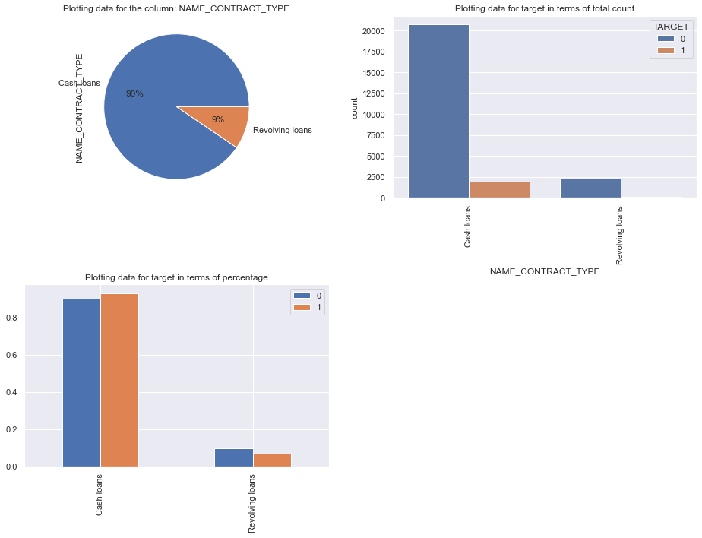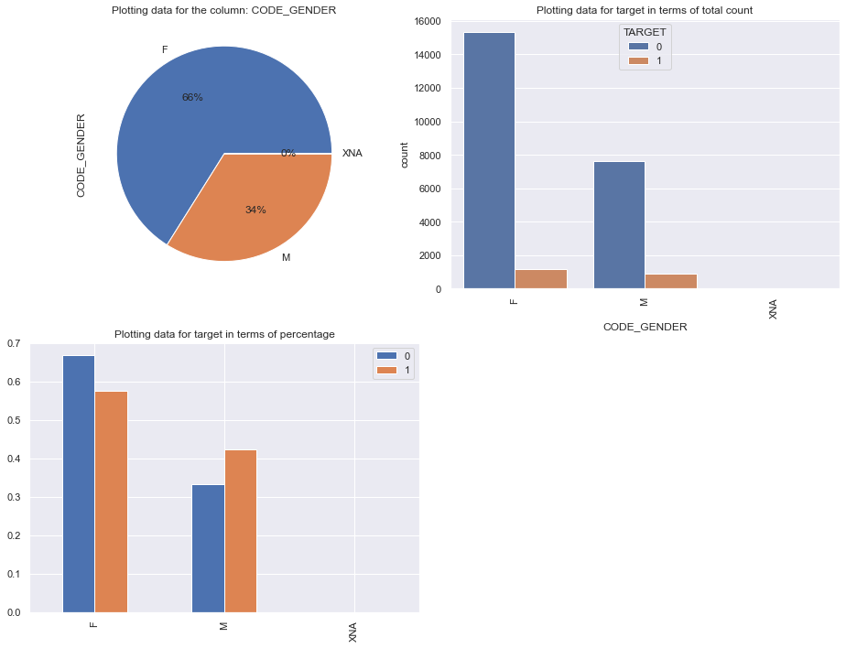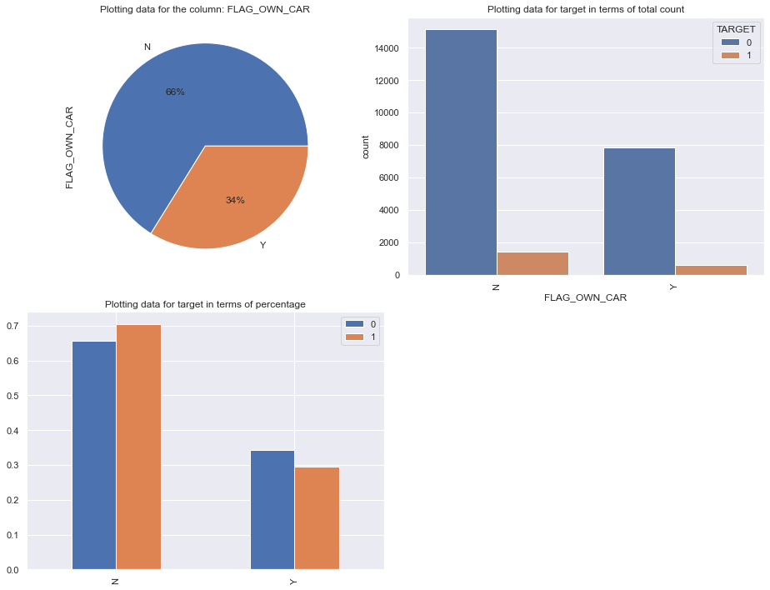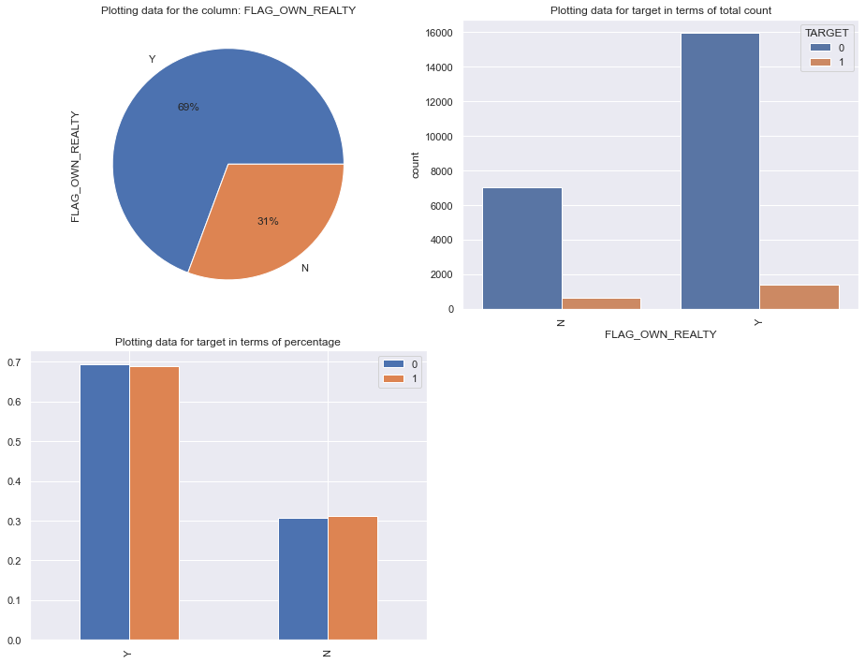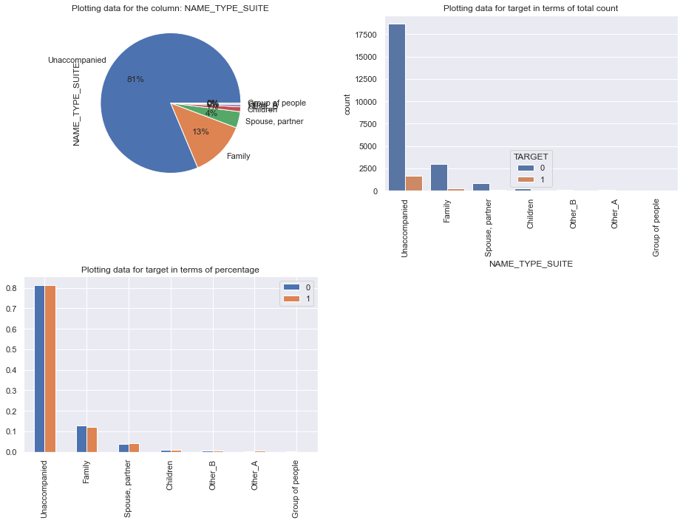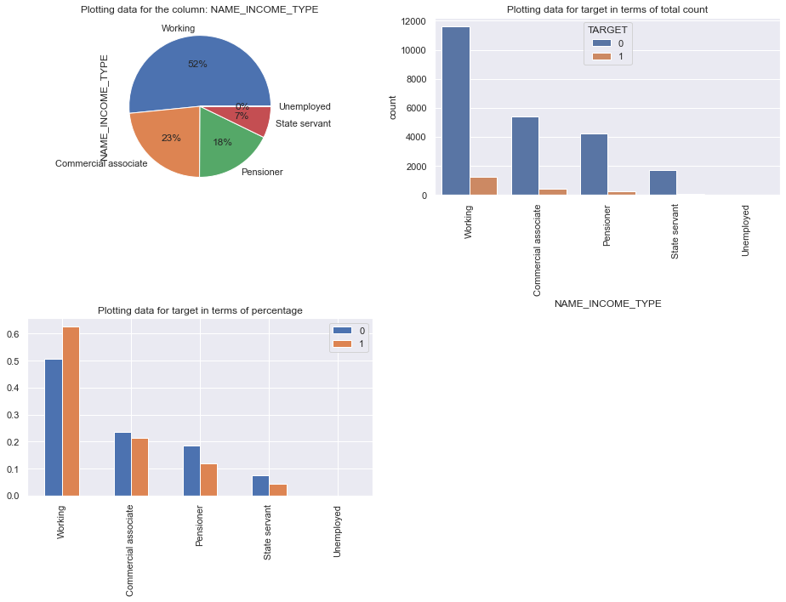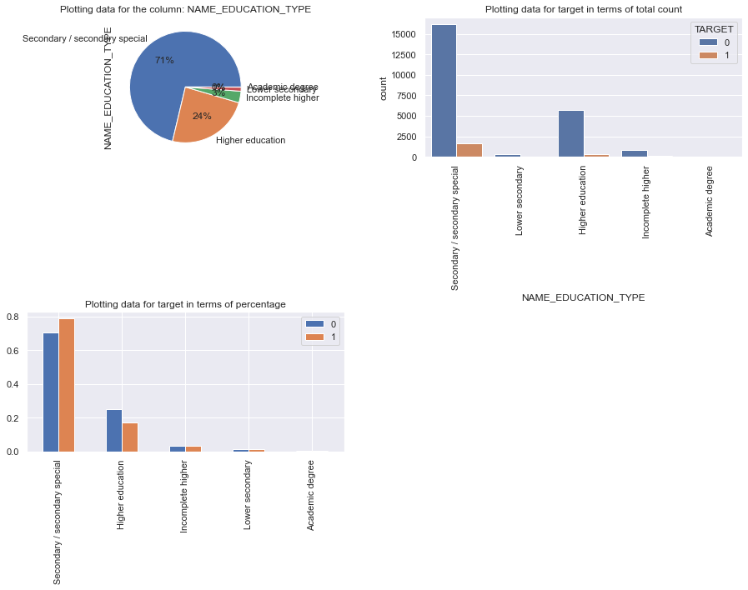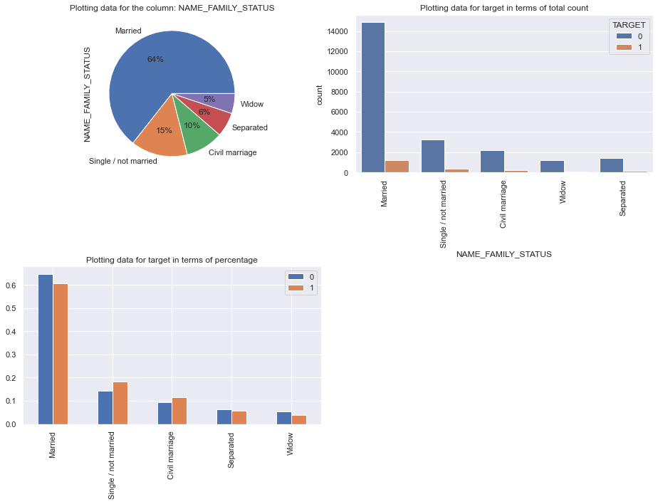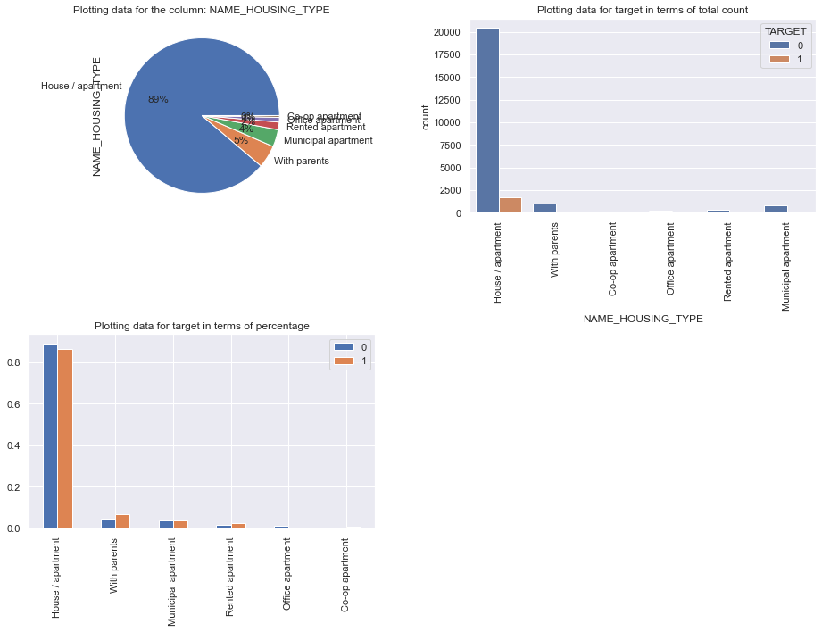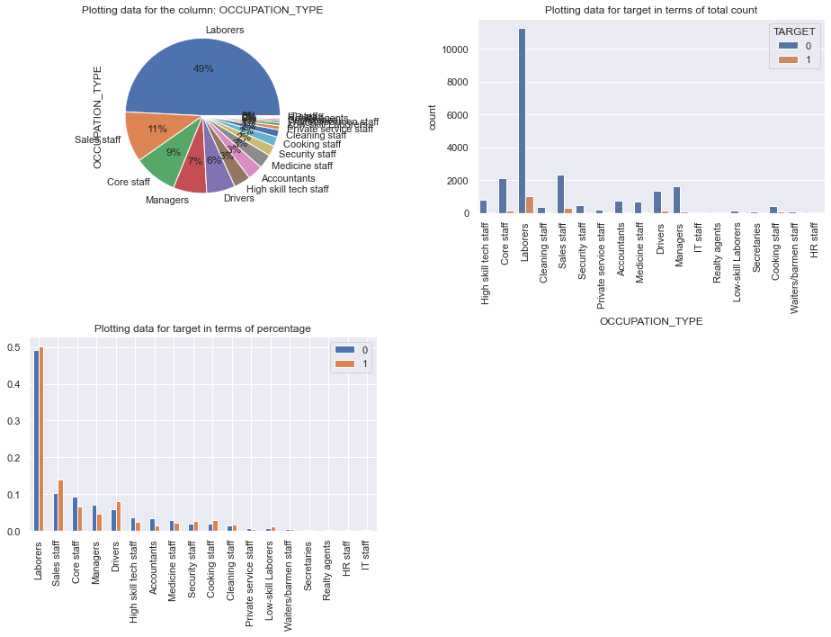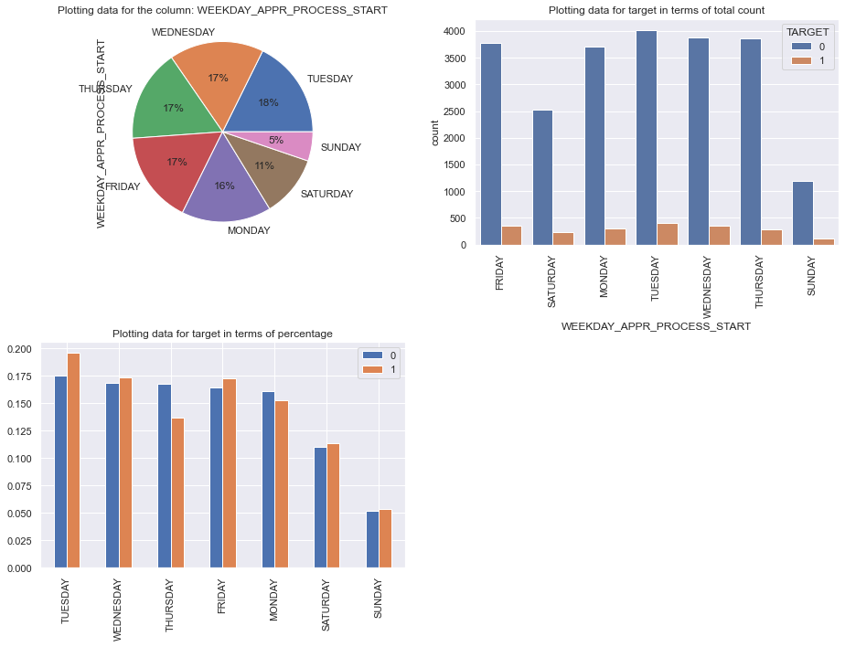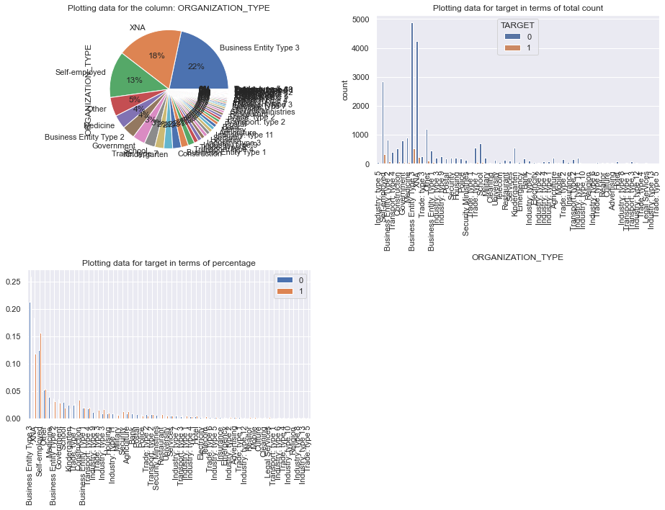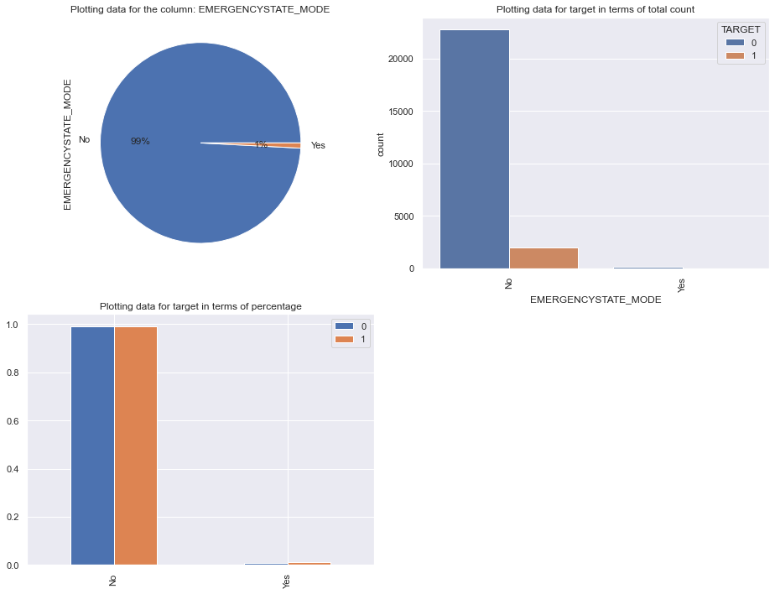

**Numerical columns**

[93]

**import** numpy **as** np  
corr = train_0.corr()  
mask = np.zeros_like(corr)  
mask[np.triu_indices_from(mask)] = True  
f, ax = plt.subplots(figsize=(11, 9))  
**with** sns.axes_style("white"):  
    ax = sns.heatmap(corr, mask=mask, vmax=.3, square=True)

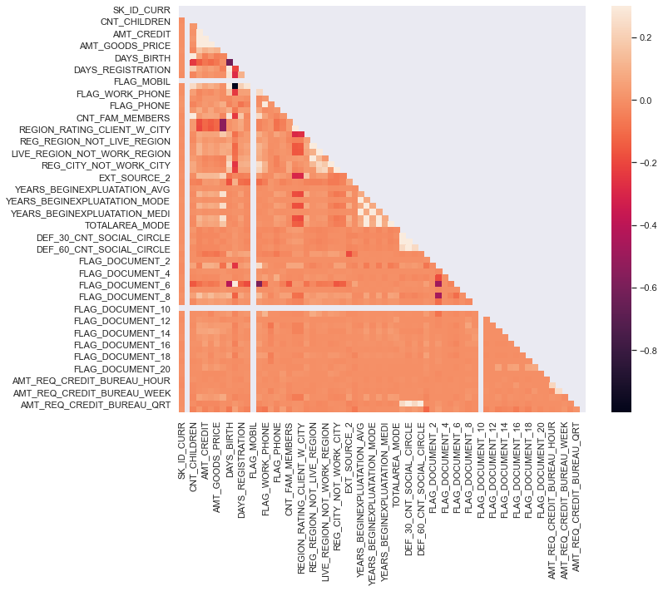

1  
-1  
0.9  
-0.9  
0.85  
0.6  
0.5  
-0.3  
  
Top 2 correlations:   
Apply abs() on every value **and** then take top2

**Finding the top 10 correlation**

[94]

train_0.corr()

[95]

train_0.corr().abs()

[96]

train_0.corr().abs().unstack()

SK_ID_CURR SK_ID_CURR 1.000000  
 TARGET NaN  
 CNT_CHILDREN 0.005076  
 AMT_INCOME_TOTAL 0.001454  
 AMT_CREDIT 0.002913  
 ...   
AMT_REQ_CREDIT_BUREAU_YEAR AMT_REQ_CREDIT_BUREAU_DAY 0.002707  
 AMT_REQ_CREDIT_BUREAU_WEEK 0.019208  
 AMT_REQ_CREDIT_BUREAU_MON 0.018483  
 AMT_REQ_CREDIT_BUREAU_QRT 0.011085  
 AMT_REQ_CREDIT_BUREAU_YEAR 1.000000  
Length: 4624, dtype: float64

[97]

train_0.corr().abs().unstack().sort_values()

FLAG_DOCUMENT_21 YEARS_BEGINEXPLUATATION_MODE 0.000005  
YEARS_BEGINEXPLUATATION_MODE FLAG_DOCUMENT_21 0.000005  
FLAG_DOCUMENT_2 AMT_REQ_CREDIT_BUREAU_WEEK 0.000006  
AMT_REQ_CREDIT_BUREAU_WEEK FLAG_DOCUMENT_2 0.000006  
FLAG_DOCUMENT_21 AMT_REQ_CREDIT_BUREAU_WEEK 0.000006  
 ...   
AMT_REQ_CREDIT_BUREAU_QRT FLAG_MOBIL NaN  
 FLAG_DOCUMENT_10 NaN  
AMT_REQ_CREDIT_BUREAU_YEAR TARGET NaN  
 FLAG_MOBIL NaN  
 FLAG_DOCUMENT_10 NaN  
Length: 4624, dtype: float64

[98]

correlation_0 = train_0.corr().abs().unstack().sort_values().dropna()  
correlation_0

FLAG_DOCUMENT_21 YEARS_BEGINEXPLUATATION_MODE 0.000005  
YEARS_BEGINEXPLUATATION_MODE FLAG_DOCUMENT_21 0.000005  
FLAG_DOCUMENT_2 AMT_REQ_CREDIT_BUREAU_WEEK 0.000006  
AMT_REQ_CREDIT_BUREAU_WEEK FLAG_DOCUMENT_2 0.000006  
FLAG_DOCUMENT_21 AMT_REQ_CREDIT_BUREAU_WEEK 0.000006  
 ...   
DEF_30_CNT_SOCIAL_CIRCLE DEF_30_CNT_SOCIAL_CIRCLE 1.000000  
OBS_30_CNT_SOCIAL_CIRCLE OBS_30_CNT_SOCIAL_CIRCLE 1.000000  
TOTALAREA_MODE TOTALAREA_MODE 1.000000  
FLAG_DOCUMENT_9 FLAG_DOCUMENT_9 1.000000  
AMT_REQ_CREDIT_BUREAU_YEAR AMT_REQ_CREDIT_BUREAU_YEAR 1.000000  
Length: 4225, dtype: float64

[99]

correlation_0 = correlation_0[ correlation_0 != 1.0 ]  
  
print(correlation_0)

FLAG_DOCUMENT_21 YEARS_BEGINEXPLUATATION_MODE 0.000005  
YEARS_BEGINEXPLUATATION_MODE FLAG_DOCUMENT_21 0.000005  
FLAG_DOCUMENT_2 AMT_REQ_CREDIT_BUREAU_WEEK 0.000006  
AMT_REQ_CREDIT_BUREAU_WEEK FLAG_DOCUMENT_2 0.000006  
FLAG_DOCUMENT_21 AMT_REQ_CREDIT_BUREAU_WEEK 0.000006  
 ...   
OBS_30_CNT_SOCIAL_CIRCLE OBS_60_CNT_SOCIAL_CIRCLE 0.998270  
DEF_60_CNT_SOCIAL_CIRCLE AMT_REQ_CREDIT_BUREAU_QRT 0.999850  
AMT_REQ_CREDIT_BUREAU_QRT DEF_60_CNT_SOCIAL_CIRCLE 0.999850  
DAYS_EMPLOYED FLAG_EMP_PHONE 0.999890  
FLAG_EMP_PHONE DAYS_EMPLOYED 0.999890  
Length: 4160, dtype: float64

*#### Top correlations*  
'''  
EXT_SOURCE_1                 DAYS_BIRTH                     0.601210  
  
DAYS_EMPLOYED                DAYS_BIRTH                     0.618048  
  
AMT_CREDIT                   AMT_ANNUITY                    0.771309  
  
AMT_GOODS_PRICE              AMT_ANNUITY                    0.776686  
  
LIVE_CITY_NOT_WORK_CITY      REG_CITY_NOT_WORK_CITY         0.830381  
  
LIVE_REGION_NOT_WORK_REGION  REG_REGION_NOT_WORK_REGION     0.861861  
  
CNT_FAM_MEMBERS              CNT_CHILDREN                   0.878571  
  
REGION_RATING_CLIENT_W_CITY  REGION_RATING_CLIENT           0.950149  
  
AMT_CREDIT                   AMT_GOODS_PRICE                0.987250  
  
DAYS_EMPLOYED                FLAG_EMP_PHONE                 0.999758  
'''

*### Top correlations for the defaulter*  
'''  
EXT_SOURCE_1                 DAYS_BIRTH                     0.570054  
  
DAYS_EMPLOYED                DAYS_BIRTH                     0.575097  
  
FLAG_EMP_PHONE               DAYS_BIRTH                     0.578519  
  
AMT_CREDIT                   AMT_ANNUITY                    0.752195  
  
AMT_GOODS_PRICE              AMT_ANNUITY                    0.752699  
  
REG_CITY_NOT_WORK_CITY       LIVE_CITY_NOT_WORK_CITY        0.778540  
  
REG_REGION_NOT_WORK_REGION   LIVE_REGION_NOT_WORK_REGION    0.847885  
  
CNT_CHILDREN                 CNT_FAM_MEMBERS                0.885484  
  
REGION_RATING_CLIENT_W_CITY  REGION_RATING_CLIENT           0.956637  
  
AMT_CREDIT                   AMT_GOODS_PRICE                0.983103  
  
DAYS_EMPLOYED                FLAG_EMP_PHONE                 0.999702  
'''

**Defaulter correlation**

[100]

corr = train_1.corr()  
mask = np.zeros_like(corr)  
mask[np.triu_indices_from(mask)] = True  
f, ax = plt.subplots(figsize=(11, 9))  
**with** sns.axes_style("white"):  
    ax = sns.heatmap(corr, mask=mask, vmax=.3, square=True)

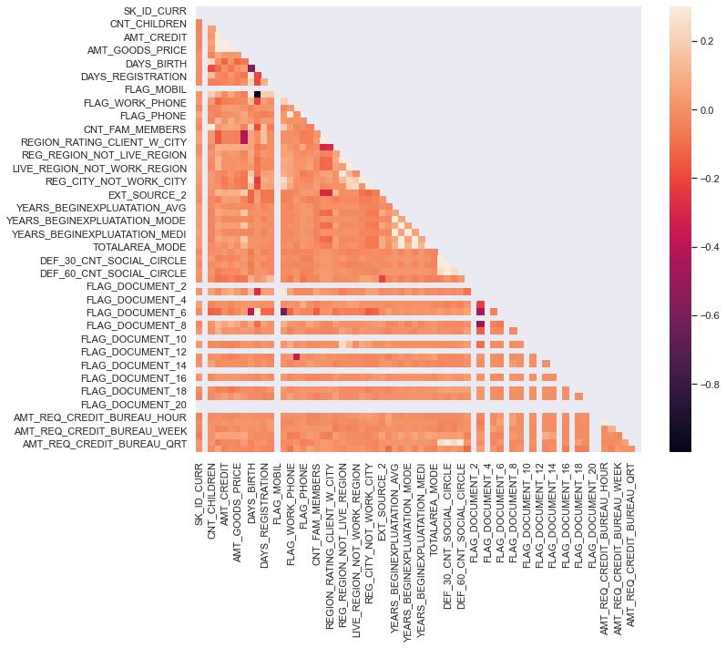

[101]

correlation_1 = train_1.corr().abs()  
correlation_1 = correlation_1.unstack().sort_values(kind="quicksort")  
correlation_1 = correlation_1.dropna()  
correlation_1 = correlation_1[correlation_1 != 1.0]  
  
print(correlation_1)

LIVE_CITY_NOT_WORK_CITY OBS_60_CNT_SOCIAL_CIRCLE 0.000009  
OBS_60_CNT_SOCIAL_CIRCLE LIVE_CITY_NOT_WORK_CITY 0.000009  
TOTALAREA_MODE AMT_CREDIT 0.000100  
AMT_CREDIT TOTALAREA_MODE 0.000100  
AMT_REQ_CREDIT_BUREAU_HOUR FLAG_WORK_PHONE 0.000223  
 ...   
FLOORSMAX_AVG FLOORSMAX_MEDI 0.998744  
YEARS_BEGINEXPLUATATION_MEDI YEARS_BEGINEXPLUATATION_MODE 0.999742  
YEARS_BEGINEXPLUATATION_MODE YEARS_BEGINEXPLUATATION_MEDI 0.999742  
DAYS_EMPLOYED FLAG_EMP_PHONE 0.999896  
FLAG_EMP_PHONE DAYS_EMPLOYED 0.999896  
Length: 3190, dtype: float64

**Analysing through box plot**

[102]

train_categorical = application_train.select_dtypes(include=['int64', 'float64']).columns

[103]

train_categorical

Index(['SK_ID_CURR', 'TARGET', 'CNT_CHILDREN', 'AMT_INCOME_TOTAL',  
 'AMT_CREDIT', 'AMT_ANNUITY', 'AMT_GOODS_PRICE',  
 'REGION_POPULATION_RELATIVE', 'DAYS_BIRTH', 'DAYS_EMPLOYED',  
 'DAYS_REGISTRATION', 'DAYS_ID_PUBLISH', 'FLAG_MOBIL', 'FLAG_EMP_PHONE',  
 'FLAG_WORK_PHONE', 'FLAG_CONT_MOBILE', 'FLAG_PHONE', 'FLAG_EMAIL',  
 'CNT_FAM_MEMBERS', 'REGION_RATING_CLIENT',  
 'REGION_RATING_CLIENT_W_CITY', 'HOUR_APPR_PROCESS_START',  
 'REG_REGION_NOT_LIVE_REGION', 'REG_REGION_NOT_WORK_REGION',  
 'LIVE_REGION_NOT_WORK_REGION', 'REG_CITY_NOT_LIVE_CITY',  
 'REG_CITY_NOT_WORK_CITY', 'LIVE_CITY_NOT_WORK_CITY', 'EXT_SOURCE_2',  
 'EXT_SOURCE_3', 'YEARS_BEGINEXPLUATATION_AVG', 'FLOORSMAX_AVG',  
 'YEARS_BEGINEXPLUATATION_MODE', 'FLOORSMAX_MODE',  
 'YEARS_BEGINEXPLUATATION_MEDI', 'FLOORSMAX_MEDI', 'TOTALAREA_MODE',  
 'OBS_30_CNT_SOCIAL_CIRCLE', 'DEF_30_CNT_SOCIAL_CIRCLE',  
 'OBS_60_CNT_SOCIAL_CIRCLE', 'DEF_60_CNT_SOCIAL_CIRCLE',  
 'DAYS_LAST_PHONE_CHANGE', 'FLAG_DOCUMENT_2', 'FLAG_DOCUMENT_3',  
 'FLAG_DOCUMENT_4', 'FLAG_DOCUMENT_5', 'FLAG_DOCUMENT_6',  
 'FLAG_DOCUMENT_7', 'FLAG_DOCUMENT_8', 'FLAG_DOCUMENT_9',  
 'FLAG_DOCUMENT_10', 'FLAG_DOCUMENT_11', 'FLAG_DOCUMENT_12',  
 'FLAG_DOCUMENT_13', 'FLAG_DOCUMENT_14', 'FLAG_DOCUMENT_15',  
 'FLAG_DOCUMENT_16', 'FLAG_DOCUMENT_17', 'FLAG_DOCUMENT_18',  
 'FLAG_DOCUMENT_19', 'FLAG_DOCUMENT_20', 'FLAG_DOCUMENT_21',  
 'AMT_REQ_CREDIT_BUREAU_HOUR', 'AMT_REQ_CREDIT_BUREAU_DAY',  
 'AMT_REQ_CREDIT_BUREAU_WEEK', 'AMT_REQ_CREDIT_BUREAU_MON',  
 'AMT_REQ_CREDIT_BUREAU_QRT', 'AMT_REQ_CREDIT_BUREAU_YEAR'],  
 dtype='object')

**Analysis for the outliers**

Potting the numerial data based on the index **and** analysing **if** there are outliers **in** any of the column.

[104]

**for** column **in** train_categorical:  
    title = "Plot of "+column  
    plt.scatter(application_train.index, application_train[column])  
    plt.title(title)  
    plt.show()

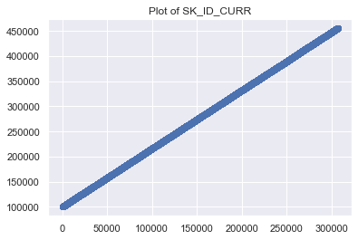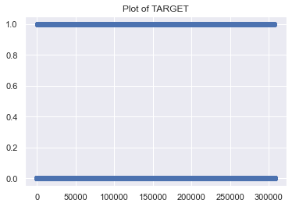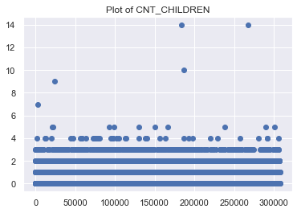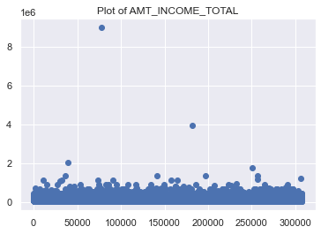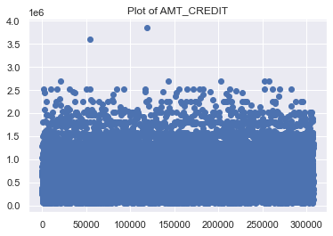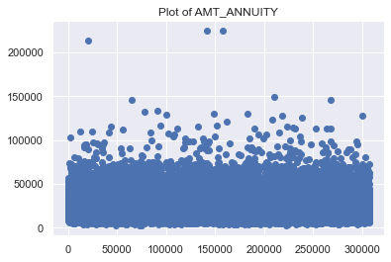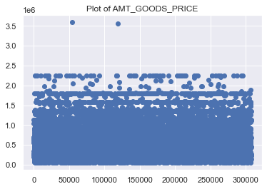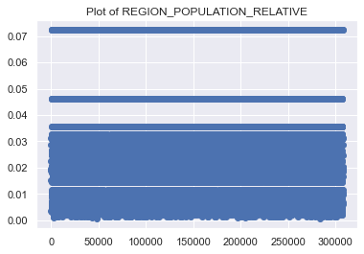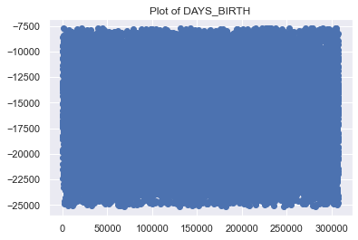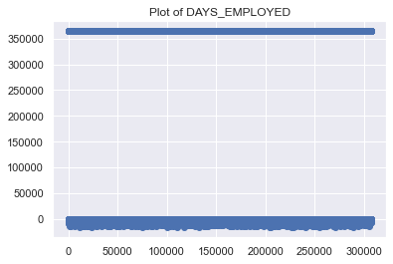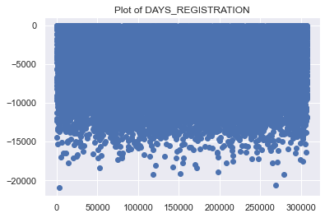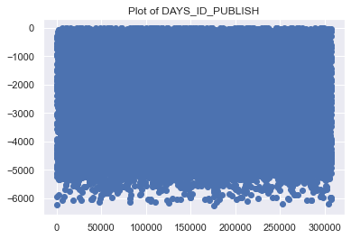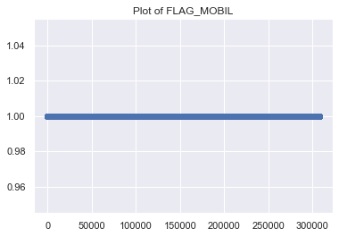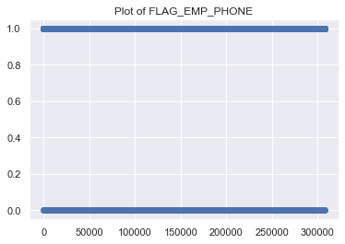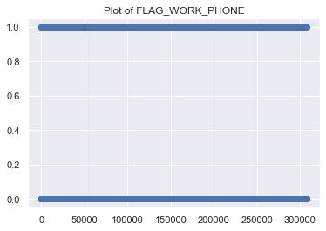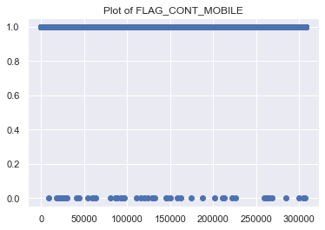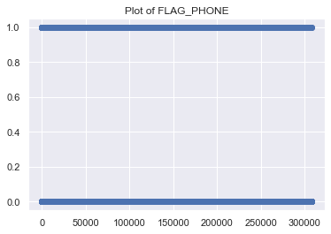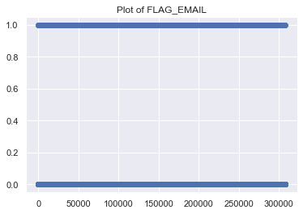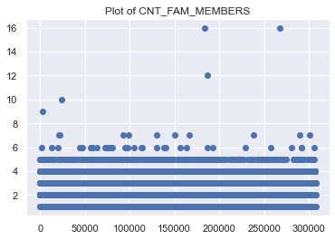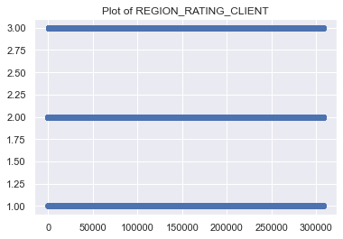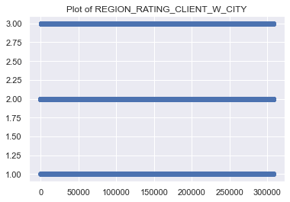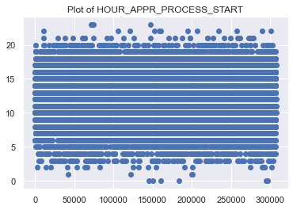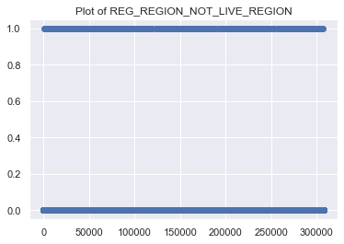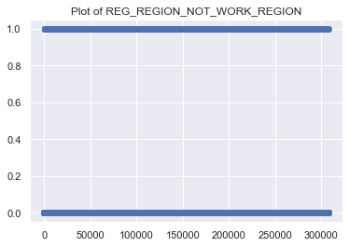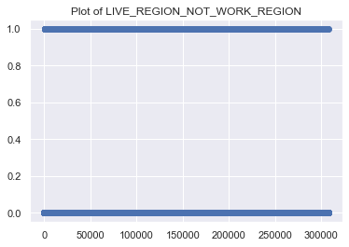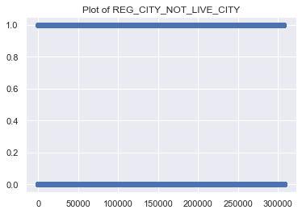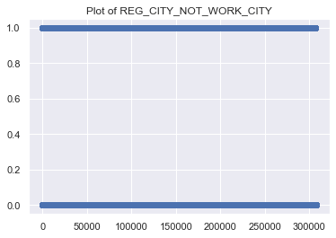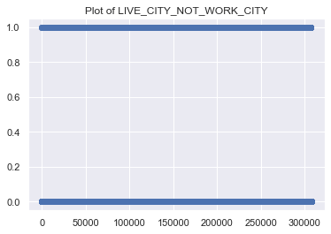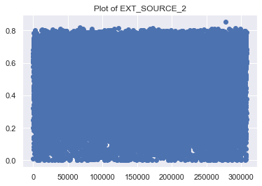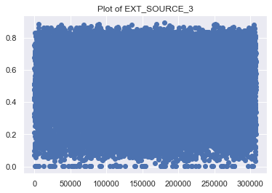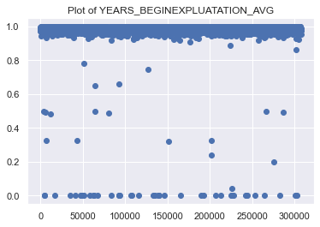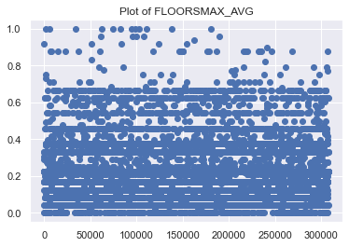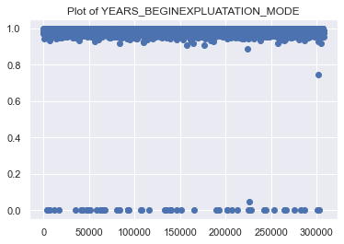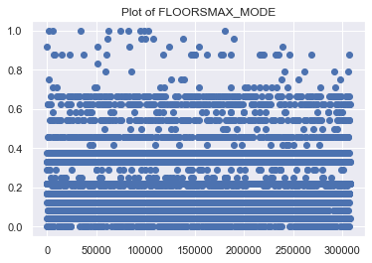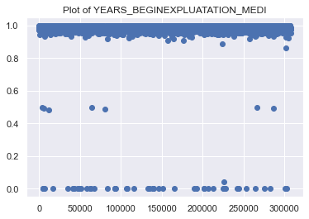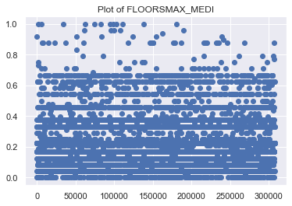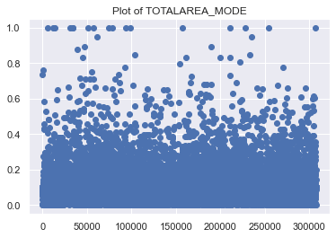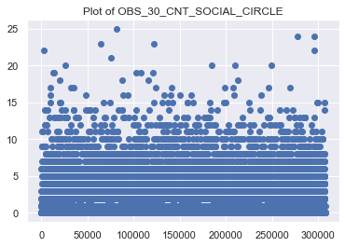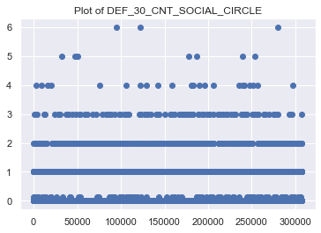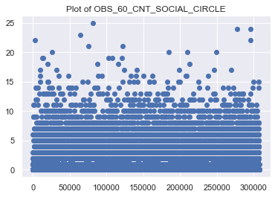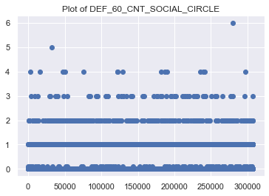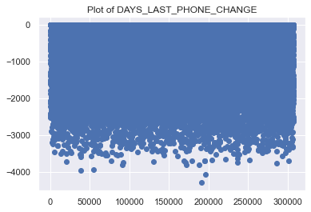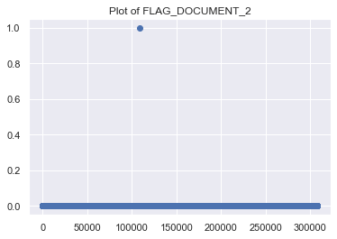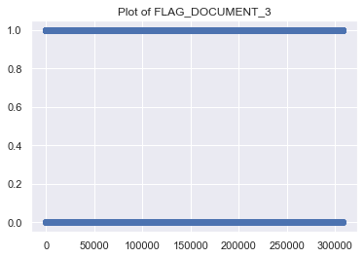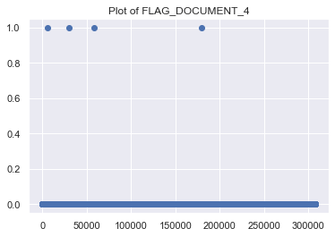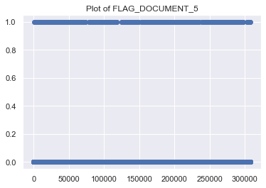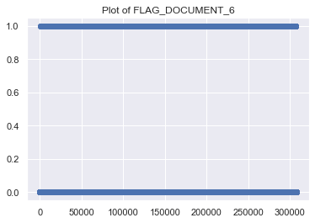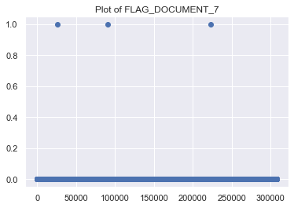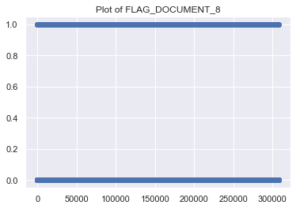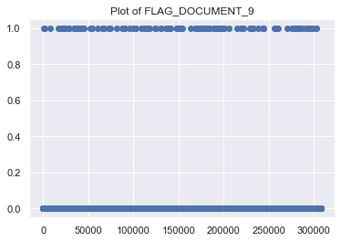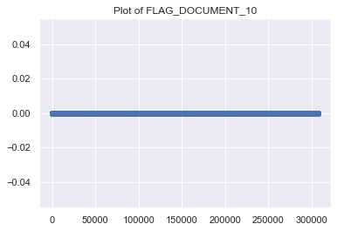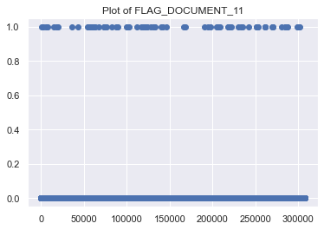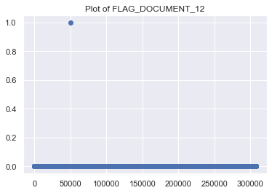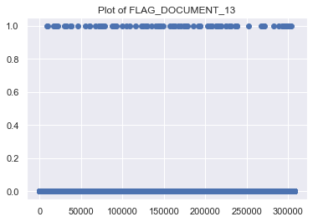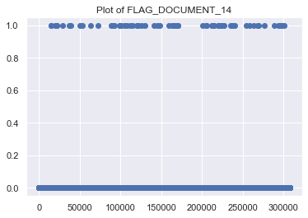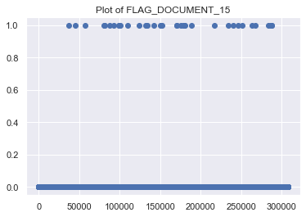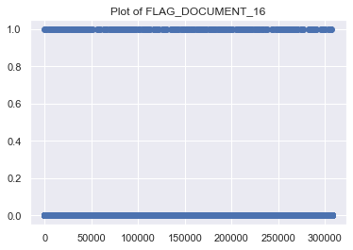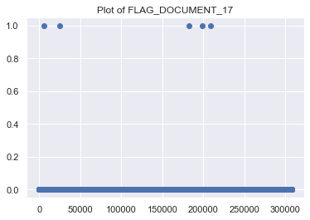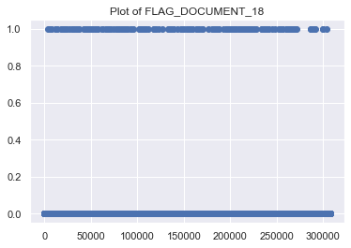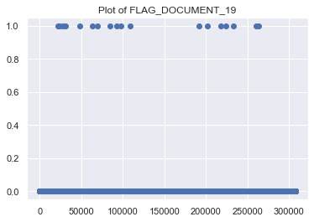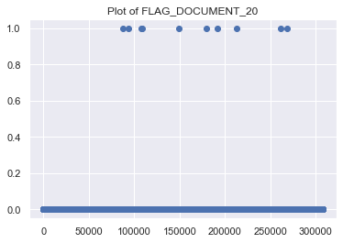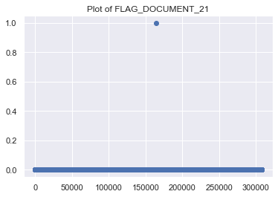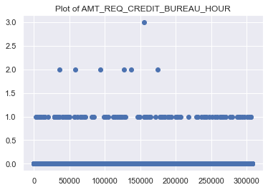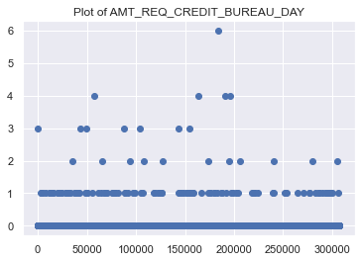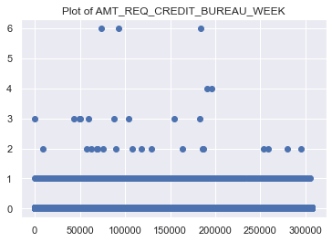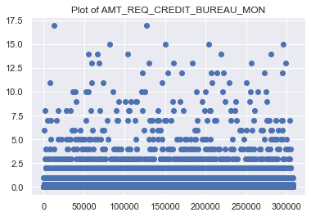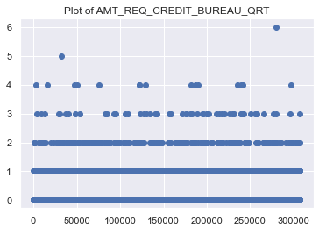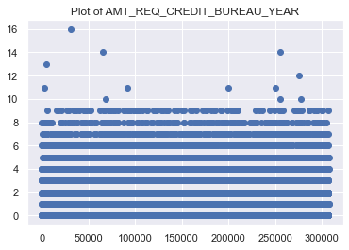

**Converting a numerical data to categorical for analysis**

[105]

<matplotlib.axes._subplots.AxesSubplot at 0x25d626f0a00>

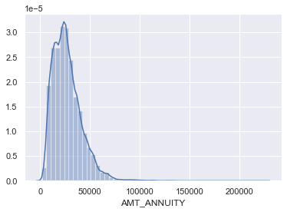

[106]

**def** amt_annuity(x):  
    **if** x<20000:  
        **return** "low"  
    **elif** x>20k **and** <=50k  
    medium  
    **elif** x>50k **and** <=1lakh  
    high  
    **else**:  
        very high  
  
application_train['amt_annuity_categorical'] = apply the above function

[107]

*# countplot*

<matplotlib.axes._subplots.AxesSubplot at 0x25d64295a90>

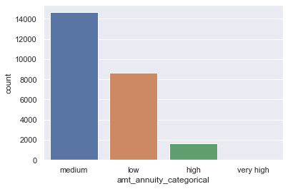

**Univariate Analysis for numerical data**

For univariate analysis of the numerical columns, we will plot the histogram and the distribution plot.

[108]

**for** column **in** train_categorical:  
    title = "Plot of "+column  
    print(title)  
    plt.hist(train_0[column], alpha=0.5, label='0')  
    plt.hist(train_1[column], alpha=0.5, label='1')  
    plt.show()  
      
    sns.distplot(train_0[column].dropna(), label='0')  
    sns.distplot(train_1[column].dropna(),  label='1')  
      
    plt.show()  
    *#box_plot(train_0, train_1, column)*  
    print("------------------------------------------------------------------------")

Plot of SK_ID_CURR

------------------------------------------------------------------------  
Plot of TARGET

C:\Users\ingle\anaconda3\lib\site-packages\seaborn\distributions.py:283: UserWarning: Data must have variance to compute a kernel density estimate.  
 warnings.warn(msg, UserWarning)  
C:\Users\ingle\anaconda3\lib\site-packages\seaborn\distributions.py:283: UserWarning: Data must have variance to compute a kernel density estimate.  
 warnings.warn(msg, UserWarning)

------------------------------------------------------------------------  
Plot of CNT_CHILDREN

------------------------------------------------------------------------  
Plot of AMT_INCOME_TOTAL

------------------------------------------------------------------------  
Plot of AMT_CREDIT

------------------------------------------------------------------------  
Plot of AMT_ANNUITY

------------------------------------------------------------------------  
Plot of AMT_GOODS_PRICE

------------------------------------------------------------------------  
Plot of REGION_POPULATION_RELATIVE

------------------------------------------------------------------------  
Plot of DAYS_BIRTH

------------------------------------------------------------------------  
Plot of DAYS_EMPLOYED

------------------------------------------------------------------------  
Plot of DAYS_REGISTRATION

------------------------------------------------------------------------  
Plot of DAYS_ID_PUBLISH

------------------------------------------------------------------------  
Plot of FLAG_MOBIL

C:\Users\ingle\anaconda3\lib\site-packages\seaborn\distributions.py:283: UserWarning: Data must have variance to compute a kernel density estimate.  
 warnings.warn(msg, UserWarning)  
C:\Users\ingle\anaconda3\lib\site-packages\seaborn\distributions.py:283: UserWarning: Data must have variance to compute a kernel density estimate.  
 warnings.warn(msg, UserWarning)

------------------------------------------------------------------------  
Plot of FLAG_EMP_PHONE

C:\Users\ingle\anaconda3\lib\site-packages\seaborn\distributions.py:369: UserWarning: Default bandwidth for data is 0; skipping density estimation.  
 warnings.warn(msg, UserWarning)  
C:\Users\ingle\anaconda3\lib\site-packages\seaborn\distributions.py:369: UserWarning: Default bandwidth for data is 0; skipping density estimation.  
 warnings.warn(msg, UserWarning)

------------------------------------------------------------------------  
Plot of FLAG_WORK_PHONE

C:\Users\ingle\anaconda3\lib\site-packages\seaborn\distributions.py:369: UserWarning: Default bandwidth for data is 0; skipping density estimation.  
 warnings.warn(msg, UserWarning)  
C:\Users\ingle\anaconda3\lib\site-packages\seaborn\distributions.py:369: UserWarning: Default bandwidth for data is 0; skipping density estimation.  
 warnings.warn(msg, UserWarning)

------------------------------------------------------------------------  
Plot of FLAG_CONT_MOBILE

C:\Users\ingle\anaconda3\lib\site-packages\seaborn\distributions.py:369: UserWarning: Default bandwidth for data is 0; skipping density estimation.  
 warnings.warn(msg, UserWarning)  
C:\Users\ingle\anaconda3\lib\site-packages\seaborn\distributions.py:369: UserWarning: Default bandwidth for data is 0; skipping density estimation.  
 warnings.warn(msg, UserWarning)

------------------------------------------------------------------------  
Plot of FLAG_PHONE

C:\Users\ingle\anaconda3\lib\site-packages\seaborn\distributions.py:369: UserWarning: Default bandwidth for data is 0; skipping density estimation.  
 warnings.warn(msg, UserWarning)

------------------------------------------------------------------------  
Plot of FLAG_EMAIL

C:\Users\ingle\anaconda3\lib\site-packages\seaborn\distributions.py:369: UserWarning: Default bandwidth for data is 0; skipping density estimation.  
 warnings.warn(msg, UserWarning)  
C:\Users\ingle\anaconda3\lib\site-packages\seaborn\distributions.py:369: UserWarning: Default bandwidth for data is 0; skipping density estimation.  
 warnings.warn(msg, UserWarning)

------------------------------------------------------------------------  
Plot of CNT_FAM_MEMBERS

------------------------------------------------------------------------  
Plot of REGION_RATING_CLIENT

C:\Users\ingle\anaconda3\lib\site-packages\seaborn\distributions.py:369: UserWarning: Default bandwidth for data is 0; skipping density estimation.  
 warnings.warn(msg, UserWarning)  
C:\Users\ingle\anaconda3\lib\site-packages\seaborn\distributions.py:369: UserWarning: Default bandwidth for data is 0; skipping density estimation.  
 warnings.warn(msg, UserWarning)

------------------------------------------------------------------------  
Plot of REGION_RATING_CLIENT_W_CITY

C:\Users\ingle\anaconda3\lib\site-packages\seaborn\distributions.py:369: UserWarning: Default bandwidth for data is 0; skipping density estimation.  
 warnings.warn(msg, UserWarning)  
C:\Users\ingle\anaconda3\lib\site-packages\seaborn\distributions.py:369: UserWarning: Default bandwidth for data is 0; skipping density estimation.  
 warnings.warn(msg, UserWarning)

------------------------------------------------------------------------  
Plot of HOUR_APPR_PROCESS_START

------------------------------------------------------------------------  
Plot of REG_REGION_NOT_LIVE_REGION

C:\Users\ingle\anaconda3\lib\site-packages\seaborn\distributions.py:369: UserWarning: Default bandwidth for data is 0; skipping density estimation.  
 warnings.warn(msg, UserWarning)  
C:\Users\ingle\anaconda3\lib\site-packages\seaborn\distributions.py:369: UserWarning: Default bandwidth for data is 0; skipping density estimation.  
 warnings.warn(msg, UserWarning)

------------------------------------------------------------------------  
Plot of REG_REGION_NOT_WORK_REGION

C:\Users\ingle\anaconda3\lib\site-packages\seaborn\distributions.py:369: UserWarning: Default bandwidth for data is 0; skipping density estimation.  
 warnings.warn(msg, UserWarning)  
C:\Users\ingle\anaconda3\lib\site-packages\seaborn\distributions.py:369: UserWarning: Default bandwidth for data is 0; skipping density estimation.  
 warnings.warn(msg, UserWarning)

------------------------------------------------------------------------  
Plot of LIVE_REGION_NOT_WORK_REGION

C:\Users\ingle\anaconda3\lib\site-packages\seaborn\distributions.py:369: UserWarning: Default bandwidth for data is 0; skipping density estimation.  
 warnings.warn(msg, UserWarning)  
C:\Users\ingle\anaconda3\lib\site-packages\seaborn\distributions.py:369: UserWarning: Default bandwidth for data is 0; skipping density estimation.  
 warnings.warn(msg, UserWarning)

------------------------------------------------------------------------  
Plot of REG_CITY_NOT_LIVE_CITY

C:\Users\ingle\anaconda3\lib\site-packages\seaborn\distributions.py:369: UserWarning: Default bandwidth for data is 0; skipping density estimation.  
 warnings.warn(msg, UserWarning)  
C:\Users\ingle\anaconda3\lib\site-packages\seaborn\distributions.py:369: UserWarning: Default bandwidth for data is 0; skipping density estimation.  
 warnings.warn(msg, UserWarning)

------------------------------------------------------------------------  
Plot of REG_CITY_NOT_WORK_CITY

C:\Users\ingle\anaconda3\lib\site-packages\seaborn\distributions.py:369: UserWarning: Default bandwidth for data is 0; skipping density estimation.  
 warnings.warn(msg, UserWarning)

------------------------------------------------------------------------  
Plot of LIVE_CITY_NOT_WORK_CITY

C:\Users\ingle\anaconda3\lib\site-packages\seaborn\distributions.py:369: UserWarning: Default bandwidth for data is 0; skipping density estimation.  
 warnings.warn(msg, UserWarning)  
C:\Users\ingle\anaconda3\lib\site-packages\seaborn\distributions.py:369: UserWarning: Default bandwidth for data is 0; skipping density estimation.  
 warnings.warn(msg, UserWarning)

------------------------------------------------------------------------  
Plot of EXT_SOURCE_2

------------------------------------------------------------------------  
Plot of EXT_SOURCE_3

------------------------------------------------------------------------  
Plot of YEARS_BEGINEXPLUATATION_AVG

------------------------------------------------------------------------  
Plot of FLOORSMAX_AVG

------------------------------------------------------------------------  
Plot of YEARS_BEGINEXPLUATATION_MODE

------------------------------------------------------------------------  
Plot of FLOORSMAX_MODE

------------------------------------------------------------------------  
Plot of YEARS_BEGINEXPLUATATION_MEDI

------------------------------------------------------------------------  
Plot of FLOORSMAX_MEDI

------------------------------------------------------------------------  
Plot of TOTALAREA_MODE

------------------------------------------------------------------------  
Plot of OBS_30_CNT_SOCIAL_CIRCLE

------------------------------------------------------------------------  
Plot of DEF_30_CNT_SOCIAL_CIRCLE

C:\Users\ingle\anaconda3\lib\site-packages\seaborn\distributions.py:369: UserWarning: Default bandwidth for data is 0; skipping density estimation.  
 warnings.warn(msg, UserWarning)  
C:\Users\ingle\anaconda3\lib\site-packages\seaborn\distributions.py:369: UserWarning: Default bandwidth for data is 0; skipping density estimation.  
 warnings.warn(msg, UserWarning)

------------------------------------------------------------------------  
Plot of OBS_60_CNT_SOCIAL_CIRCLE

------------------------------------------------------------------------  
Plot of DEF_60_CNT_SOCIAL_CIRCLE

C:\Users\ingle\anaconda3\lib\site-packages\seaborn\distributions.py:369: UserWarning: Default bandwidth for data is 0; skipping density estimation.  
 warnings.warn(msg, UserWarning)  
C:\Users\ingle\anaconda3\lib\site-packages\seaborn\distributions.py:369: UserWarning: Default bandwidth for data is 0; skipping density estimation.  
 warnings.warn(msg, UserWarning)

------------------------------------------------------------------------  
Plot of DAYS_LAST_PHONE_CHANGE

------------------------------------------------------------------------  
Plot of FLAG_DOCUMENT_2

C:\Users\ingle\anaconda3\lib\site-packages\seaborn\distributions.py:369: UserWarning: Default bandwidth for data is 0; skipping density estimation.  
 warnings.warn(msg, UserWarning)  
C:\Users\ingle\anaconda3\lib\site-packages\seaborn\distributions.py:283: UserWarning: Data must have variance to compute a kernel density estimate.  
 warnings.warn(msg, UserWarning)

------------------------------------------------------------------------  
Plot of FLAG_DOCUMENT_3

C:\Users\ingle\anaconda3\lib\site-packages\seaborn\distributions.py:369: UserWarning: Default bandwidth for data is 0; skipping density estimation.  
 warnings.warn(msg, UserWarning)

------------------------------------------------------------------------  
Plot of FLAG_DOCUMENT_4

C:\Users\ingle\anaconda3\lib\site-packages\seaborn\distributions.py:369: UserWarning: Default bandwidth for data is 0; skipping density estimation.  
 warnings.warn(msg, UserWarning)  
C:\Users\ingle\anaconda3\lib\site-packages\seaborn\distributions.py:283: UserWarning: Data must have variance to compute a kernel density estimate.  
 warnings.warn(msg, UserWarning)

------------------------------------------------------------------------  
Plot of FLAG_DOCUMENT_5

C:\Users\ingle\anaconda3\lib\site-packages\seaborn\distributions.py:369: UserWarning: Default bandwidth for data is 0; skipping density estimation.  
 warnings.warn(msg, UserWarning)  
C:\Users\ingle\anaconda3\lib\site-packages\seaborn\distributions.py:369: UserWarning: Default bandwidth for data is 0; skipping density estimation.  
 warnings.warn(msg, UserWarning)

------------------------------------------------------------------------  
Plot of FLAG_DOCUMENT_6

C:\Users\ingle\anaconda3\lib\site-packages\seaborn\distributions.py:369: UserWarning: Default bandwidth for data is 0; skipping density estimation.  
 warnings.warn(msg, UserWarning)  
C:\Users\ingle\anaconda3\lib\site-packages\seaborn\distributions.py:369: UserWarning: Default bandwidth for data is 0; skipping density estimation.  
 warnings.warn(msg, UserWarning)

------------------------------------------------------------------------  
Plot of FLAG_DOCUMENT_7

C:\Users\ingle\anaconda3\lib\site-packages\seaborn\distributions.py:369: UserWarning: Default bandwidth for data is 0; skipping density estimation.  
 warnings.warn(msg, UserWarning)  
C:\Users\ingle\anaconda3\lib\site-packages\seaborn\distributions.py:283: UserWarning: Data must have variance to compute a kernel density estimate.  
 warnings.warn(msg, UserWarning)

------------------------------------------------------------------------  
Plot of FLAG_DOCUMENT_8

C:\Users\ingle\anaconda3\lib\site-packages\seaborn\distributions.py:369: UserWarning: Default bandwidth for data is 0; skipping density estimation.  
 warnings.warn(msg, UserWarning)  
C:\Users\ingle\anaconda3\lib\site-packages\seaborn\distributions.py:369: UserWarning: Default bandwidth for data is 0; skipping density estimation.  
 warnings.warn(msg, UserWarning)

------------------------------------------------------------------------  
Plot of FLAG_DOCUMENT_9

C:\Users\ingle\anaconda3\lib\site-packages\seaborn\distributions.py:369: UserWarning: Default bandwidth for data is 0; skipping density estimation.  
 warnings.warn(msg, UserWarning)  
C:\Users\ingle\anaconda3\lib\site-packages\seaborn\distributions.py:369: UserWarning: Default bandwidth for data is 0; skipping density estimation.  
 warnings.warn(msg, UserWarning)

------------------------------------------------------------------------  
Plot of FLAG_DOCUMENT_10

C:\Users\ingle\anaconda3\lib\site-packages\seaborn\distributions.py:283: UserWarning: Data must have variance to compute a kernel density estimate.  
 warnings.warn(msg, UserWarning)  
C:\Users\ingle\anaconda3\lib\site-packages\seaborn\distributions.py:283: UserWarning: Data must have variance to compute a kernel density estimate.  
 warnings.warn(msg, UserWarning)

------------------------------------------------------------------------  
Plot of FLAG_DOCUMENT_11

C:\Users\ingle\anaconda3\lib\site-packages\seaborn\distributions.py:369: UserWarning: Default bandwidth for data is 0; skipping density estimation.  
 warnings.warn(msg, UserWarning)  
C:\Users\ingle\anaconda3\lib\site-packages\seaborn\distributions.py:369: UserWarning: Default bandwidth for data is 0; skipping density estimation.  
 warnings.warn(msg, UserWarning)

------------------------------------------------------------------------  
Plot of FLAG_DOCUMENT_12

C:\Users\ingle\anaconda3\lib\site-packages\seaborn\distributions.py:369: UserWarning: Default bandwidth for data is 0; skipping density estimation.  
 warnings.warn(msg, UserWarning)  
C:\Users\ingle\anaconda3\lib\site-packages\seaborn\distributions.py:283: UserWarning: Data must have variance to compute a kernel density estimate.  
 warnings.warn(msg, UserWarning)

------------------------------------------------------------------------  
Plot of FLAG_DOCUMENT_13

C:\Users\ingle\anaconda3\lib\site-packages\seaborn\distributions.py:369: UserWarning: Default bandwidth for data is 0; skipping density estimation.  
 warnings.warn(msg, UserWarning)  
C:\Users\ingle\anaconda3\lib\site-packages\seaborn\distributions.py:369: UserWarning: Default bandwidth for data is 0; skipping density estimation.  
 warnings.warn(msg, UserWarning)

------------------------------------------------------------------------  
Plot of FLAG_DOCUMENT_14

C:\Users\ingle\anaconda3\lib\site-packages\seaborn\distributions.py:369: UserWarning: Default bandwidth for data is 0; skipping density estimation.  
 warnings.warn(msg, UserWarning)  
C:\Users\ingle\anaconda3\lib\site-packages\seaborn\distributions.py:369: UserWarning: Default bandwidth for data is 0; skipping density estimation.  
 warnings.warn(msg, UserWarning)

------------------------------------------------------------------------  
Plot of FLAG_DOCUMENT_15

C:\Users\ingle\anaconda3\lib\site-packages\seaborn\distributions.py:369: UserWarning: Default bandwidth for data is 0; skipping density estimation.  
 warnings.warn(msg, UserWarning)  
C:\Users\ingle\anaconda3\lib\site-packages\seaborn\distributions.py:283: UserWarning: Data must have variance to compute a kernel density estimate.  
 warnings.warn(msg, UserWarning)

------------------------------------------------------------------------  
Plot of FLAG_DOCUMENT_16

C:\Users\ingle\anaconda3\lib\site-packages\seaborn\distributions.py:369: UserWarning: Default bandwidth for data is 0; skipping density estimation.  
 warnings.warn(msg, UserWarning)  
C:\Users\ingle\anaconda3\lib\site-packages\seaborn\distributions.py:369: UserWarning: Default bandwidth for data is 0; skipping density estimation.  
 warnings.warn(msg, UserWarning)

------------------------------------------------------------------------  
Plot of FLAG_DOCUMENT_17

C:\Users\ingle\anaconda3\lib\site-packages\seaborn\distributions.py:369: UserWarning: Default bandwidth for data is 0; skipping density estimation.  
 warnings.warn(msg, UserWarning)  
C:\Users\ingle\anaconda3\lib\site-packages\seaborn\distributions.py:283: UserWarning: Data must have variance to compute a kernel density estimate.  
 warnings.warn(msg, UserWarning)

------------------------------------------------------------------------  
Plot of FLAG_DOCUMENT_18

C:\Users\ingle\anaconda3\lib\site-packages\seaborn\distributions.py:369: UserWarning: Default bandwidth for data is 0; skipping density estimation.  
 warnings.warn(msg, UserWarning)  
C:\Users\ingle\anaconda3\lib\site-packages\seaborn\distributions.py:369: UserWarning: Default bandwidth for data is 0; skipping density estimation.  
 warnings.warn(msg, UserWarning)

------------------------------------------------------------------------  
Plot of FLAG_DOCUMENT_19

C:\Users\ingle\anaconda3\lib\site-packages\seaborn\distributions.py:369: UserWarning: Default bandwidth for data is 0; skipping density estimation.  
 warnings.warn(msg, UserWarning)  
C:\Users\ingle\anaconda3\lib\site-packages\seaborn\distributions.py:369: UserWarning: Default bandwidth for data is 0; skipping density estimation.  
 warnings.warn(msg, UserWarning)

------------------------------------------------------------------------  
Plot of FLAG_DOCUMENT_20

C:\Users\ingle\anaconda3\lib\site-packages\seaborn\distributions.py:369: UserWarning: Default bandwidth for data is 0; skipping density estimation.  
 warnings.warn(msg, UserWarning)  
C:\Users\ingle\anaconda3\lib\site-packages\seaborn\distributions.py:283: UserWarning: Data must have variance to compute a kernel density estimate.  
 warnings.warn(msg, UserWarning)

------------------------------------------------------------------------  
Plot of FLAG_DOCUMENT_21

C:\Users\ingle\anaconda3\lib\site-packages\seaborn\distributions.py:369: UserWarning: Default bandwidth for data is 0; skipping density estimation.  
 warnings.warn(msg, UserWarning)  
C:\Users\ingle\anaconda3\lib\site-packages\seaborn\distributions.py:283: UserWarning: Data must have variance to compute a kernel density estimate.  
 warnings.warn(msg, UserWarning)

------------------------------------------------------------------------  
Plot of AMT_REQ_CREDIT_BUREAU_HOUR

C:\Users\ingle\anaconda3\lib\site-packages\seaborn\distributions.py:369: UserWarning: Default bandwidth for data is 0; skipping density estimation.  
 warnings.warn(msg, UserWarning)  
C:\Users\ingle\anaconda3\lib\site-packages\seaborn\distributions.py:369: UserWarning: Default bandwidth for data is 0; skipping density estimation.  
 warnings.warn(msg, UserWarning)

------------------------------------------------------------------------  
Plot of AMT_REQ_CREDIT_BUREAU_DAY

C:\Users\ingle\anaconda3\lib\site-packages\seaborn\distributions.py:369: UserWarning: Default bandwidth for data is 0; skipping density estimation.  
 warnings.warn(msg, UserWarning)  
C:\Users\ingle\anaconda3\lib\site-packages\seaborn\distributions.py:369: UserWarning: Default bandwidth for data is 0; skipping density estimation.  
 warnings.warn(msg, UserWarning)

------------------------------------------------------------------------  
Plot of AMT_REQ_CREDIT_BUREAU_WEEK

C:\Users\ingle\anaconda3\lib\site-packages\seaborn\distributions.py:369: UserWarning: Default bandwidth for data is 0; skipping density estimation.  
 warnings.warn(msg, UserWarning)  
C:\Users\ingle\anaconda3\lib\site-packages\seaborn\distributions.py:369: UserWarning: Default bandwidth for data is 0; skipping density estimation.  
 warnings.warn(msg, UserWarning)

------------------------------------------------------------------------  
Plot of AMT_REQ_CREDIT_BUREAU_MON

------------------------------------------------------------------------  
Plot of AMT_REQ_CREDIT_BUREAU_QRT

C:\Users\ingle\anaconda3\lib\site-packages\seaborn\distributions.py:369: UserWarning: Default bandwidth for data is 0; skipping density estimation.  
 warnings.warn(msg, UserWarning)  
C:\Users\ingle\anaconda3\lib\site-packages\seaborn\distributions.py:369: UserWarning: Default bandwidth for data is 0; skipping density estimation.  
 warnings.warn(msg, UserWarning)

------------------------------------------------------------------------  
Plot of AMT_REQ_CREDIT_BUREAU_YEAR

------------------------------------------------------------------------

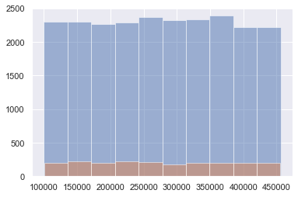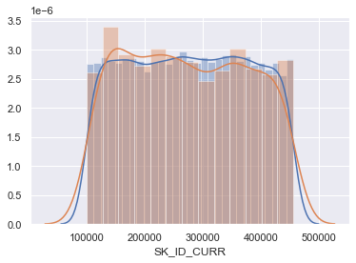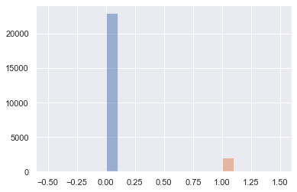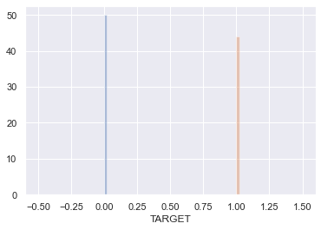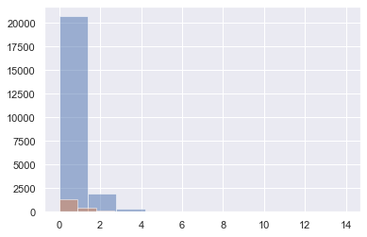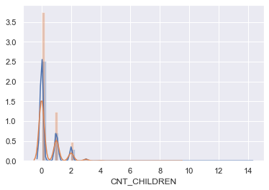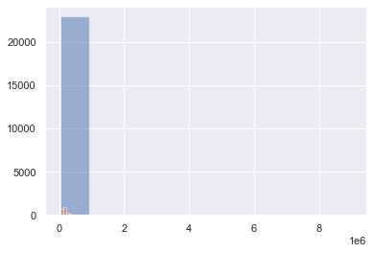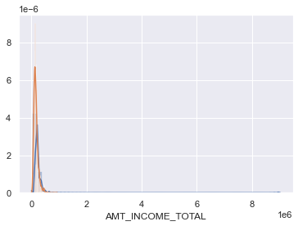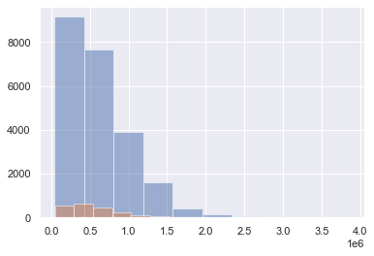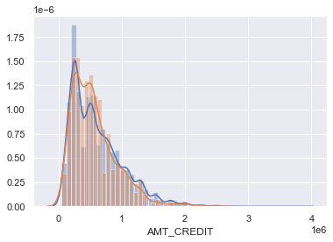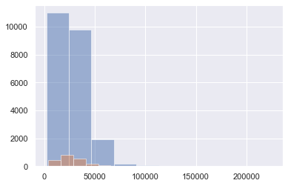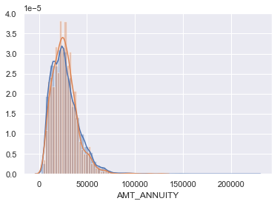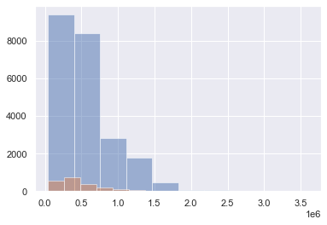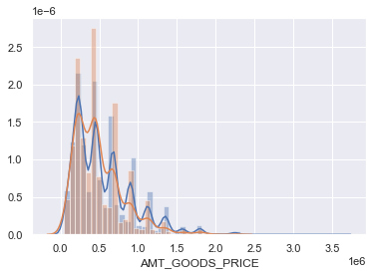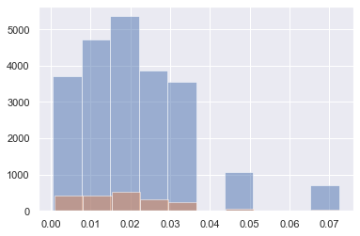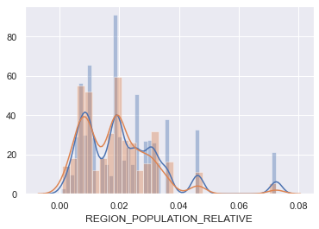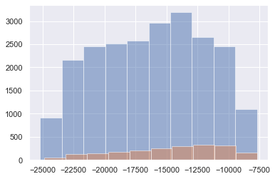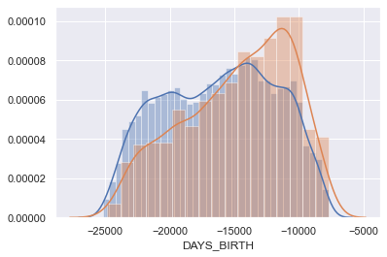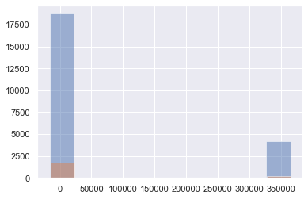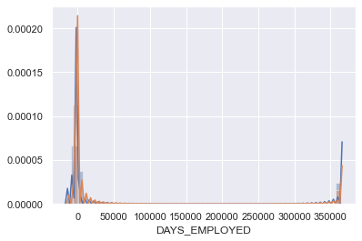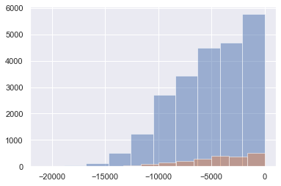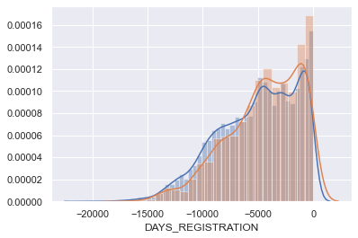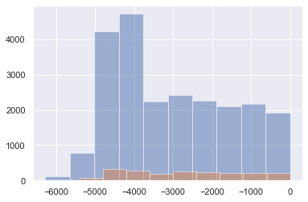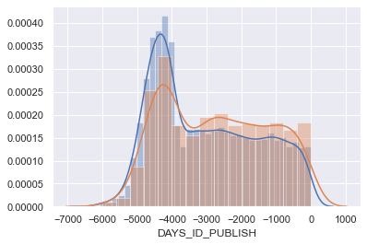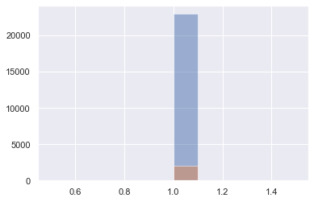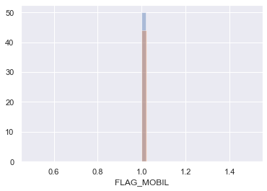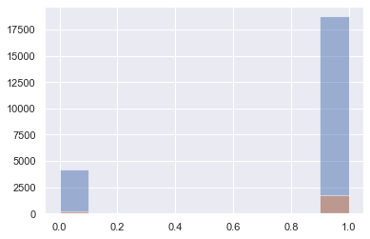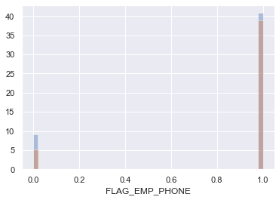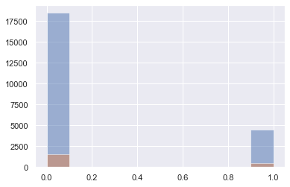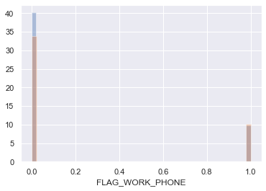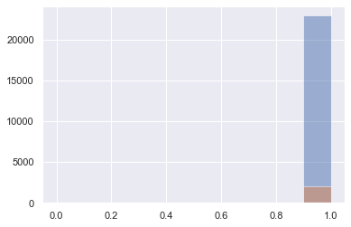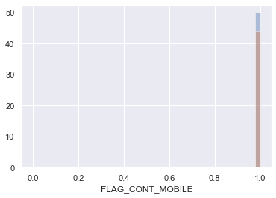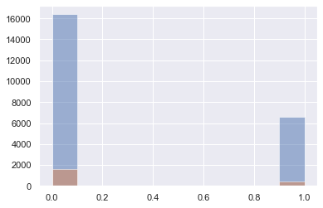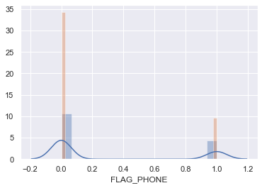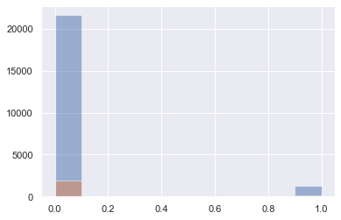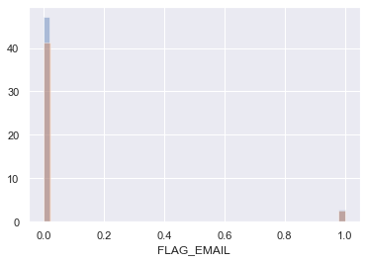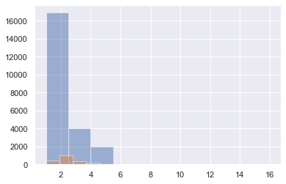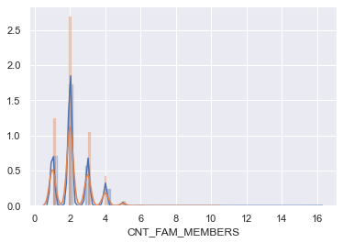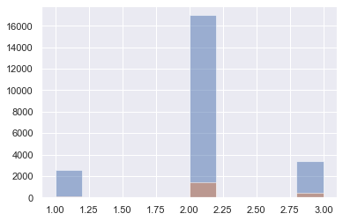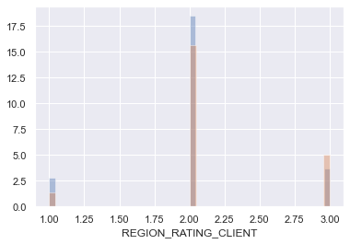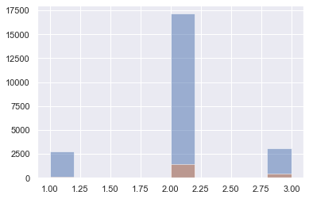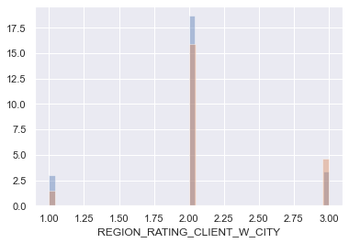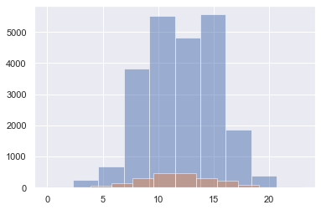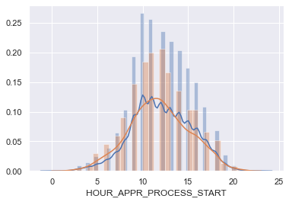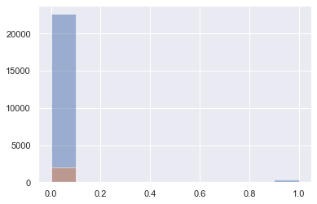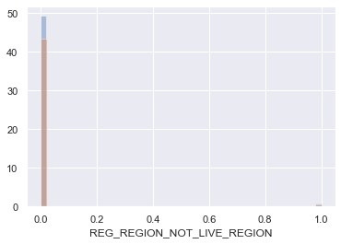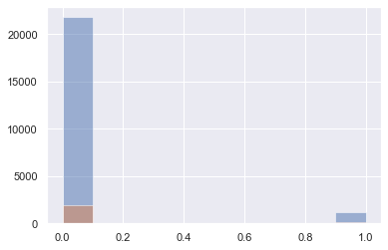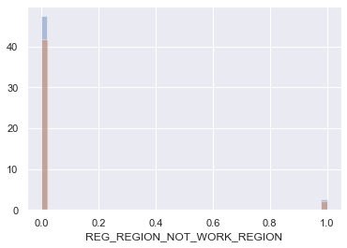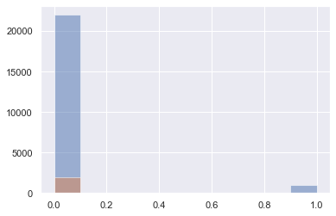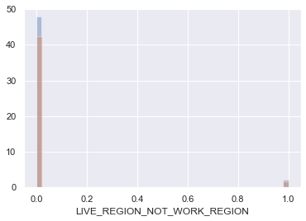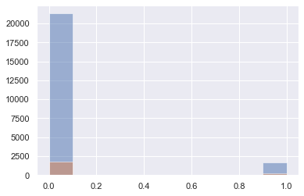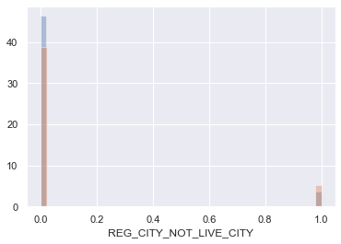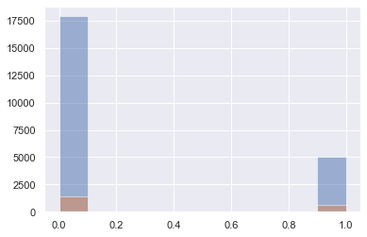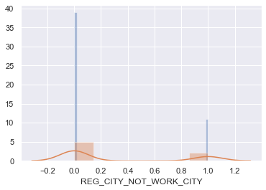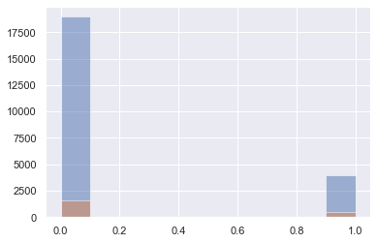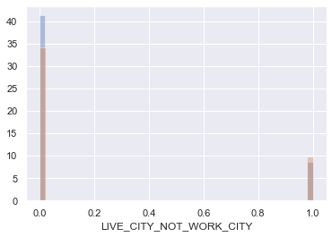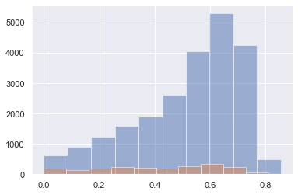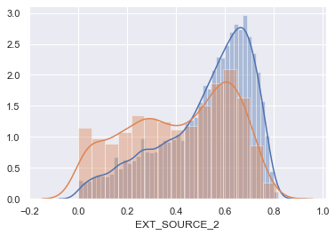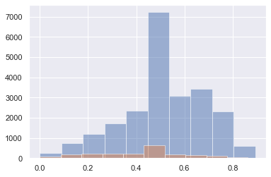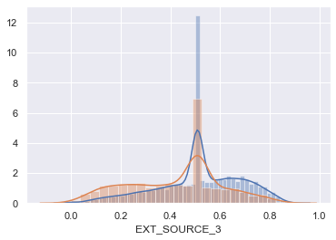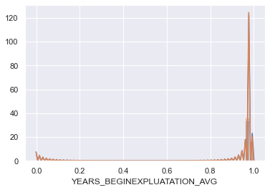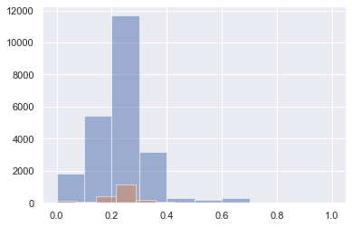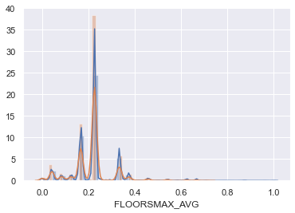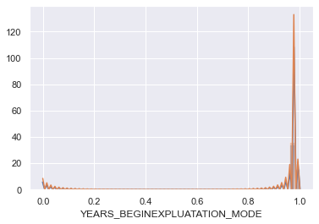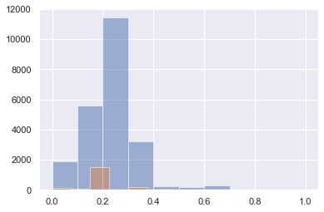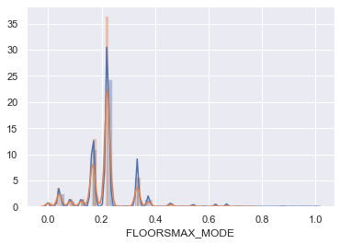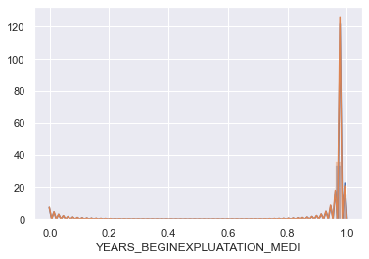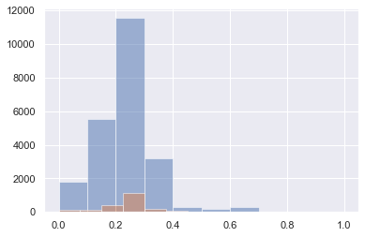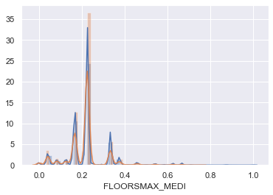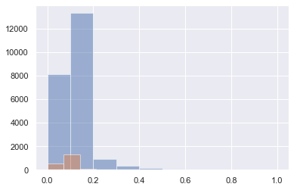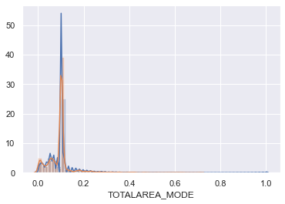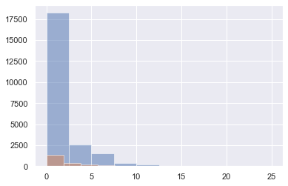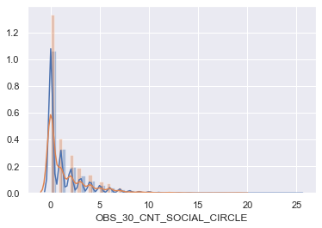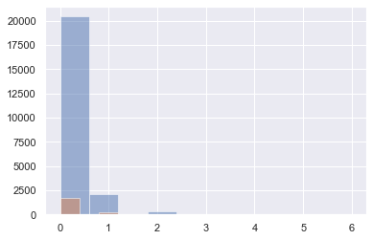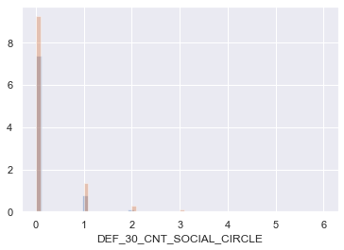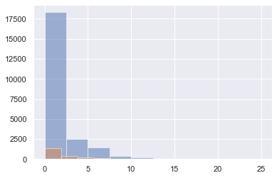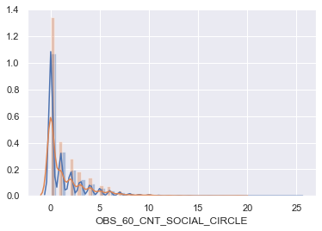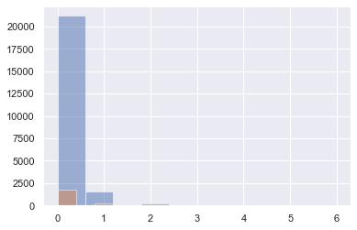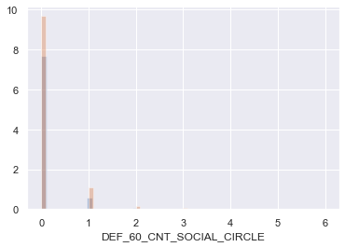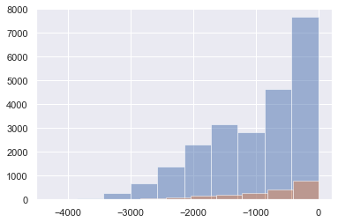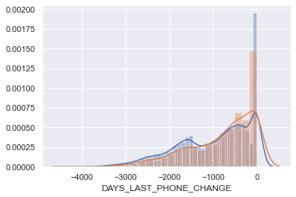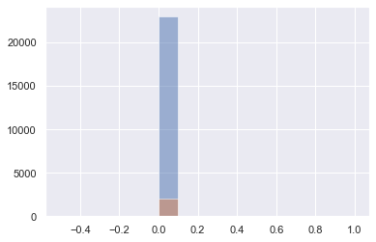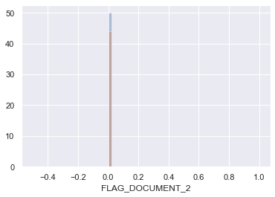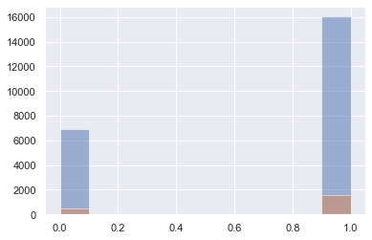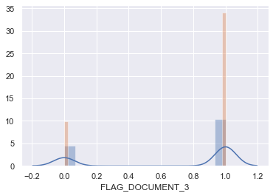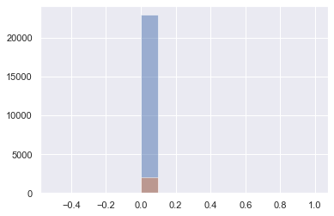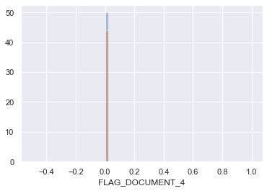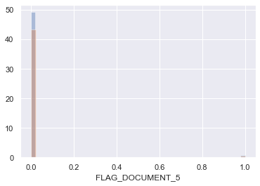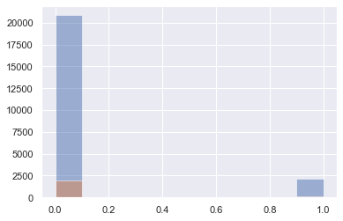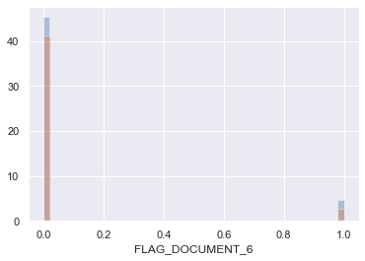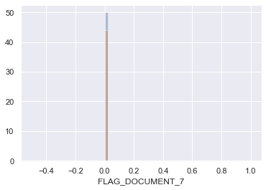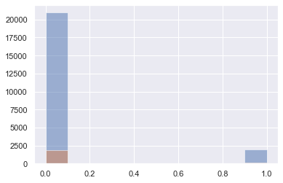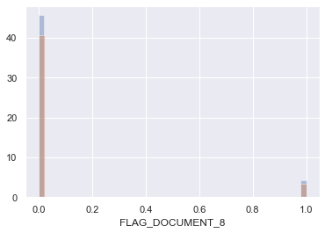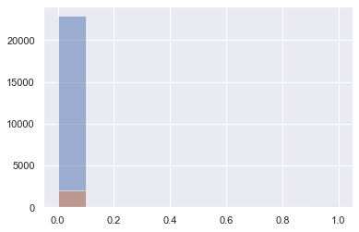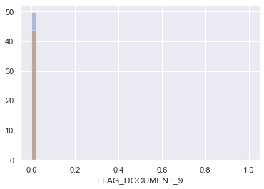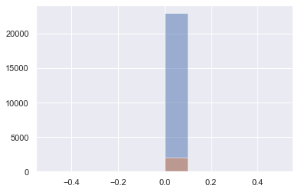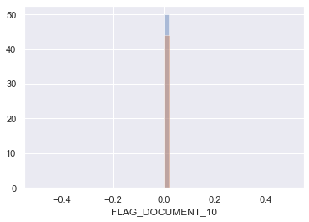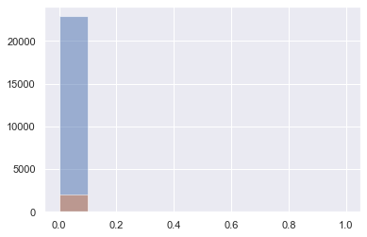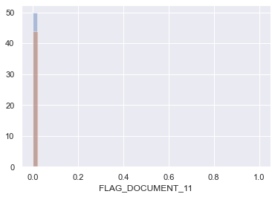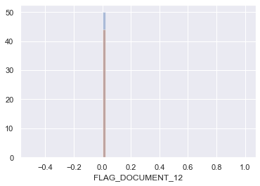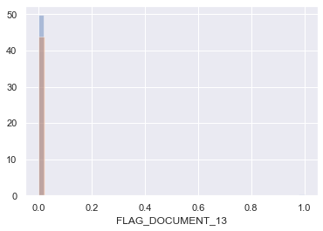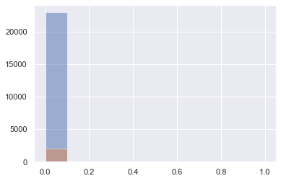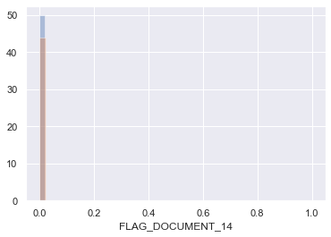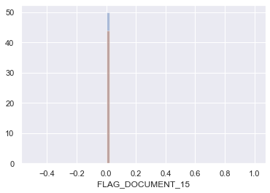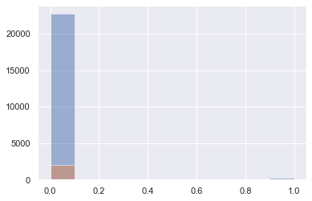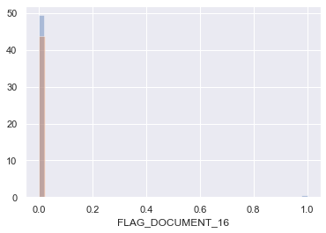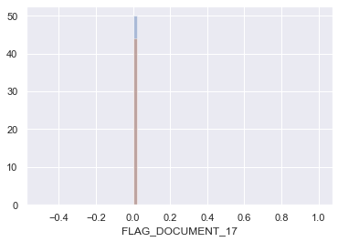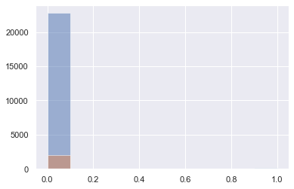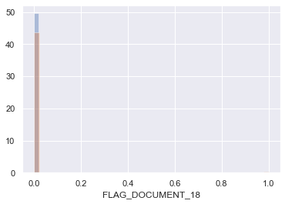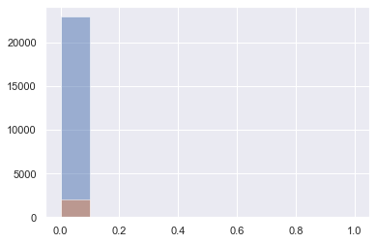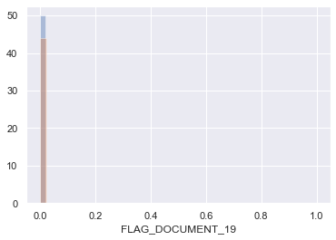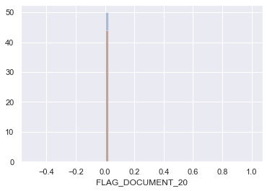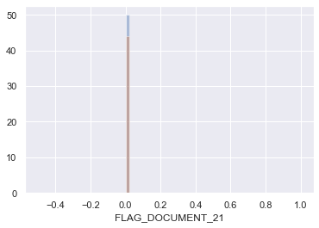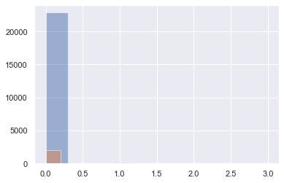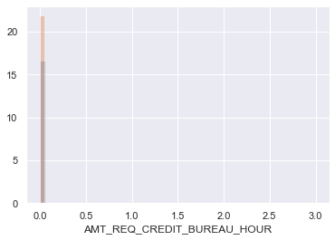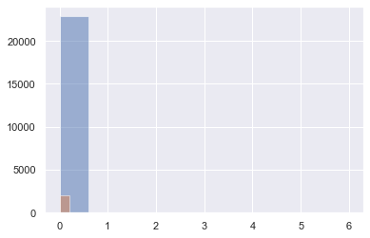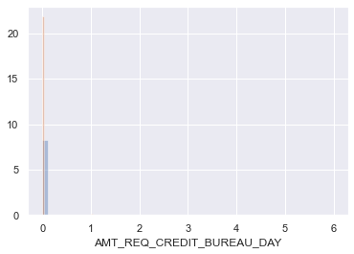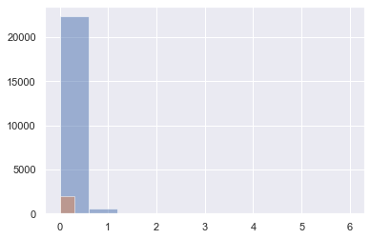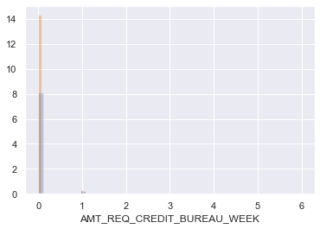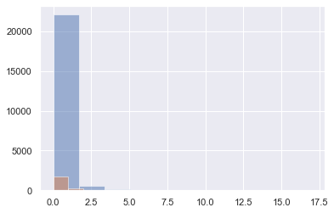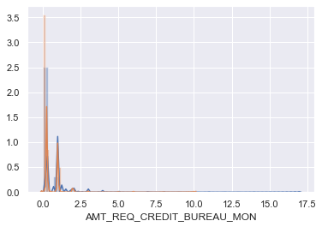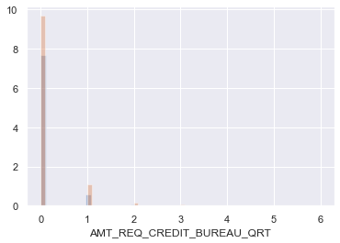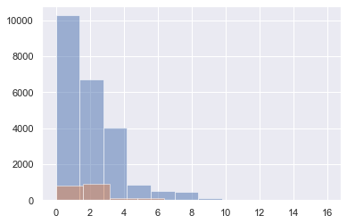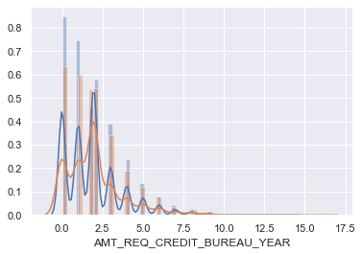

**Reading previous application**

[109]

previous_application = pd.read_csv('previous_application.csv')  
previous_application.head()

[110]

*# Shape of previous application*  
previous_application.shape

(1670214, 37)

[111]

previous_application = previous_application.sample(25000)  
previous_application.head()

[112]

previous_application.shape

(25000, 37)

[113]

previous_application1 = previous_application  
previous_application1.shape

(25000, 37)

**There are duplicate 'SK_ID_CURR' as a person could have taken loan multiple times**

[114]

*# Number of unique id in previous application*  
previous_application.SK_ID_PREV.value_counts()

1607679 1  
1029177 1  
1291346 1  
1516914 1  
2380399 1  
 ..  
1895751 1  
2683752 1  
2497699 1  
1258828 1  
1968129 1  
Name: SK_ID_PREV, Length: 25000, dtype: int64

[115]

*# Number of unique id in previous application*  
previous_application.SK_ID_CURR.value_counts()

152600 4  
327393 3  
244126 3  
387020 3  
211489 3  
 ..  
340086 1  
257079 1  
328762 1  
137390 1  
393216 1  
Name: SK_ID_CURR, Length: 23727, dtype: int64

**As you can see above, the shape of previous application is (1670214, 37) and length of SK_ID_PREV is also (1670214), but length of SK_ID_CURR is (338857), which is less than length of SK_ID_PREV, which tells us that there are duplicate number of SK_ID_PREV**

**Let's merge dataframe: train and previous application based on SK_ID_PREV**

After merging both the dataframes, the new dataframe will also have duplicate number of SK_ID_PREV. This should not be a problem, as we are trying to figure out if any pattern is present by including the cases if a lender has previously taken loan more than once.

[116]

previous_train = application_train.merge(previous_application, left_on='SK_ID_CURR',   
                                         right_on='SK_ID_CURR', how='inner')

[117]

previous_train.shape

(1748, 118)

[118]

previous_train.head()

[119]

previous_application.columns.values

array(['SK_ID_PREV', 'SK_ID_CURR', 'NAME_CONTRACT_TYPE', 'AMT_ANNUITY',  
 'AMT_APPLICATION', 'AMT_CREDIT', 'AMT_DOWN_PAYMENT',  
 'AMT_GOODS_PRICE', 'WEEKDAY_APPR_PROCESS_START',  
 'HOUR_APPR_PROCESS_START', 'FLAG_LAST_APPL_PER_CONTRACT',  
 'NFLAG_LAST_APPL_IN_DAY', 'RATE_DOWN_PAYMENT',  
 'RATE_INTEREST_PRIMARY', 'RATE_INTEREST_PRIVILEGED',  
 'NAME_CASH_LOAN_PURPOSE', 'NAME_CONTRACT_STATUS', 'DAYS_DECISION',  
 'NAME_PAYMENT_TYPE', 'CODE_REJECT_REASON', 'NAME_TYPE_SUITE',  
 'NAME_CLIENT_TYPE', 'NAME_GOODS_CATEGORY', 'NAME_PORTFOLIO',  
 'NAME_PRODUCT_TYPE', 'CHANNEL_TYPE', 'SELLERPLACE_AREA',  
 'NAME_SELLER_INDUSTRY', 'CNT_PAYMENT', 'NAME_YIELD_GROUP',  
 'PRODUCT_COMBINATION', 'DAYS_FIRST_DRAWING', 'DAYS_FIRST_DUE',  
 'DAYS_LAST_DUE_1ST_VERSION', 'DAYS_LAST_DUE', 'DAYS_TERMINATION',  
 'NFLAG_INSURED_ON_APPROVAL'], dtype=object)

**The merged dataframe also has multiple values for SK_ID_CURR**

[120]

previous_application.SK_ID_CURR.value_counts().head()

152600 4  
327393 3  
244126 3  
387020 3  
211489 3  
Name: SK_ID_CURR, dtype: int64

**Segregating the dataset on Target=0 and Target=1**

[121]

train_0 = application_train.loc[application_train['TARGET'] == 0]  
train_1 = application_train.loc[application_train['TARGET'] == 1]

[122]

ptrain_0 = previous_train.loc[previous_train['TARGET'] == 0]  
ptrain_1 = previous_train.loc[previous_train['TARGET'] == 1]

**Plotting data**

[123]

**def** plotting(column, hue):  
    col = column  
    hue = hue  
    fig = plt.figure(figsize=(13,10))  
  
    ax1 = plt.subplot(221)  
    application_train[col].value_counts().plot.pie(autopct = "%1.0f%%", ax=ax1)  
    plt.title('Plotting data for the column: '+ column)  
  
  
    ax2 = plt.subplot(222)  
    df = pd.DataFrame()  
    df['0']= ((train_0[col].value_counts())/len(train_0))  
    df['1']= ((train_1[col].value_counts())/len(train_1))  
    df.plot.bar(ax=ax2)  
    plt.title('Plotting data for target in terms of total count')  
  
  
    ax3 = plt.subplot(223)  
    sns.countplot(x=col, hue=hue, data=ptrain_0, ax = ax3)  
    plt.xticks(rotation=90)  
    plt.title('Plotting data for Target=0 in terms of percentage')  
  
    ax4 = plt.subplot(224)  
    sns.countplot(x=col, hue=hue, data=ptrain_1, ax = ax4)  
    plt.xticks(rotation=90)  
    plt.title('Plotting data for Target=1 in terms of percentage')  
  
  
  
    fig.tight_layout() *# Or equivalently,  "plt.tight_layout()"*  
  
    plt.show()

**Bivariate Analysis**

Here, plotting only **for** 3 columns, **as** plotting **in** loop **for** all columns was pretty heavy **for** this size of dataset.

**Plotting NAME_EDUCATION_TYPE**

[124]

plotting('NAME_EDUCATION_TYPE','NAME_CONTRACT_STATUS')

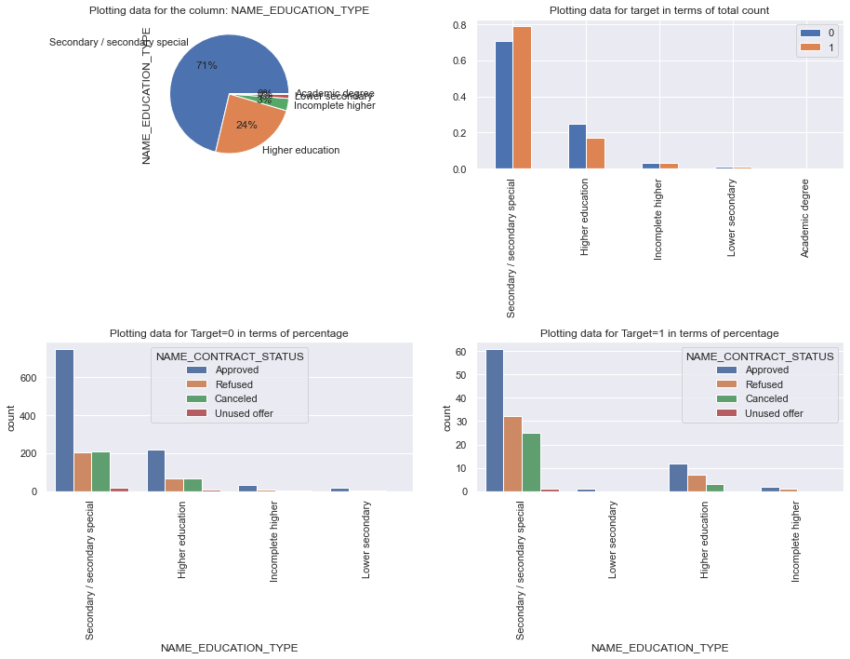

**Happy Learning**